# Week 1 : Classes and OOP

## Encrypting your work

* Download the webfolder.zip file attached below and unzip it. You only need to do this once.

<https://www.coursera.org/learn/uol-graphics-programming/ungradedLab/yipev/how-to-share-your-work-with-others-safely-regen>

* Encrypt the sketch you want to upload using the Javascript Obfuscation plugin as per the course's honour code. The obfuscator is here

<https://www.coursera.org/learn/uol-graphics-programming/ungradedLab/n2qFS/javascript-obfuscator-encrypt-your-work>

* Place the encrypted index.html generated in the appropriate subdirectory inside webfolder. Keep a safe copy of webfolder for reuse.
* Zip webfolder
* Click on "Open webpage uploader" at the top of this page and upload your code
* Press on the *Generate / Update shared link* at the bottom of this page (even if you have done so for previous uploads)
* Visit the generated link every time you update your code online or your page won't update.
* Share any directory subfolder on each assignment's discussion forum

## Work Environment

* Use this empty example to start your codes
  + C:\Work\Learn\Programming\UOL\University of London\Course\level5\2_GraphicsProgramming\emptyExample

## Using transformations

* Explain how we move an object

We move it by changing the origin of the plan. Ie by either

* Translations: Moving the origin of the coordinate space
* Rotations: Rotation the x and y axis by the same angle, while keeping the origin fixed
* Scaling: Changing the unit value on the x and y axis by the same amount
* Explain the advantage of that method

instead of adjusting all parameters of the object we change one thing only

* Show how translating works

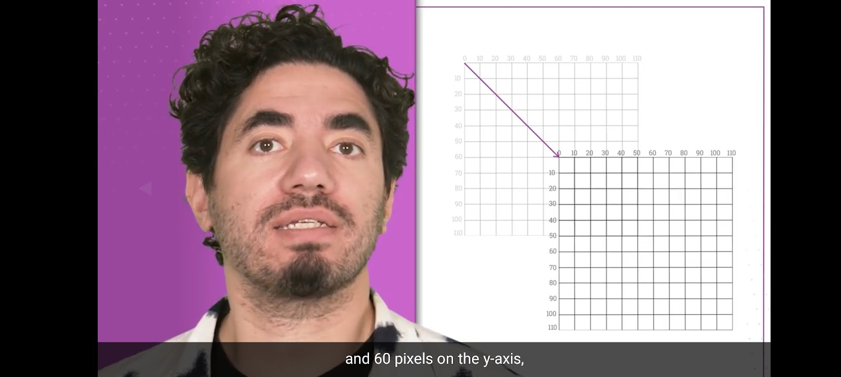

If you build a rectangle as rect(0,0,30,30) and move the translate the origin by (100,100) then the rectangle will also move by (100,100) relative to the canvas

* Create a rectangle then move it only by translating the coordinates.
* function draw() {
* translate(100,100);
* rect(0,0,100,100);
* }

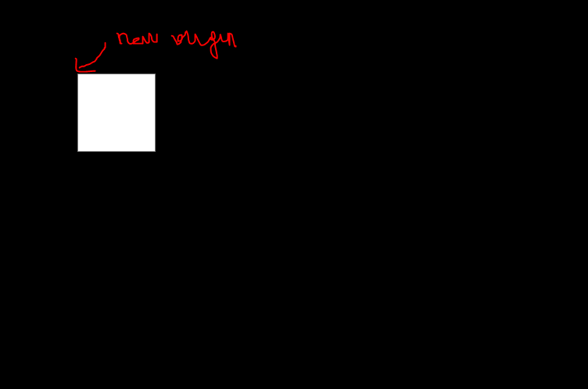

* In the cat program use translation to simplify the drawing of the cat . Change the code so that you call only drawCat() with no aguments and still have the cat follow the mouse. Hint: Use translate()
* function setup() {
* createCanvas(720, 400);
* }
* ////////////////////////////////////////////////////
* function draw() {
* background(0, 150, 200);
* drawCat(mouseX, mouseY);
* // drawCatSimpler(300, 200);
* // remove and LIVE CODE
* // for (var x=1; x<4; x++){
* //   drawCat(x*150, 200);
* // }
* }
* /////////////////////////////////////////////////////
* function drawCat(x, y){
* rectMode(CENTER);
* strokeWeight(2);
* rect(x, y, 100, 100); // face
* rect(x-20, y-20, 25, 10); // left eye
* rect(x+20, y-20, 25, 10); // right eye
* rect(x, y+5, 7, 25); // nose
* rect(x, y+30, 30, 5); // mouth
* triangle(x-50, y-50, x-30, y-70, x-10, y-50);
* triangle(x+50, y-50, x+30, y-70, x+10, y-50);
* }

*Solution*

You translate by mouseX, mouseY. And in the draw function you remove the x and y

function setup() {

    createCanvas(720, 400);

  }

  ////////////////////////////////////////////////////

  function draw() {

    background(0, 150, 200);

    translate(mouseX, mouseY)

    drawCat();

    // drawCatSimpler(300, 200);

    // remove and LIVE CODE

    // for (var x=1; x<4; x++){

    //   drawCat(x*150, 200);

    // }

  }

  /////////////////////////////////////////////////////

  function drawCat(){

    rectMode(CENTER);

    strokeWeight(2);

    rect(0, 0, 100, 100); // face

    rect(-20, -20, 25, 10); // left eye

    rect(20, -20, 25, 10); // right eye

    rect(0, 5, 7, 25); // nose

    rect(0, 30, 30, 5); // mouth

    triangle(-50, -50, -30, -70, -10, -50);

    triangle(+50, -50, 30, -70, 10, -50);

  }

* Show what à radius is. The rotate function

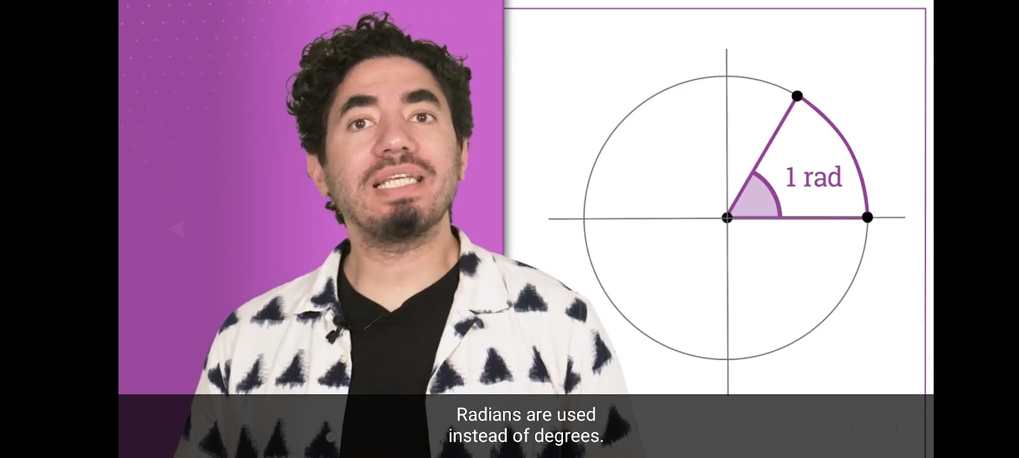

1 radian is the angle formed by the arc whose length equals the radius of the circle

* Show how rotation works

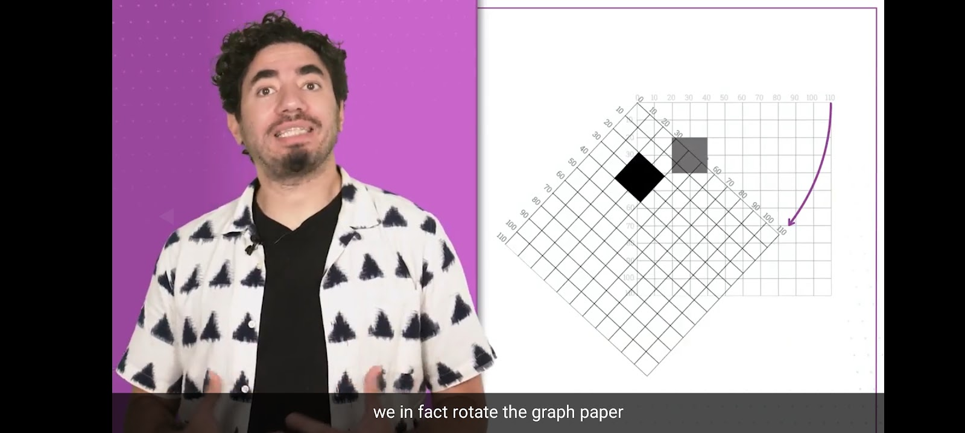

* Now create a rectangle and rotate it like this

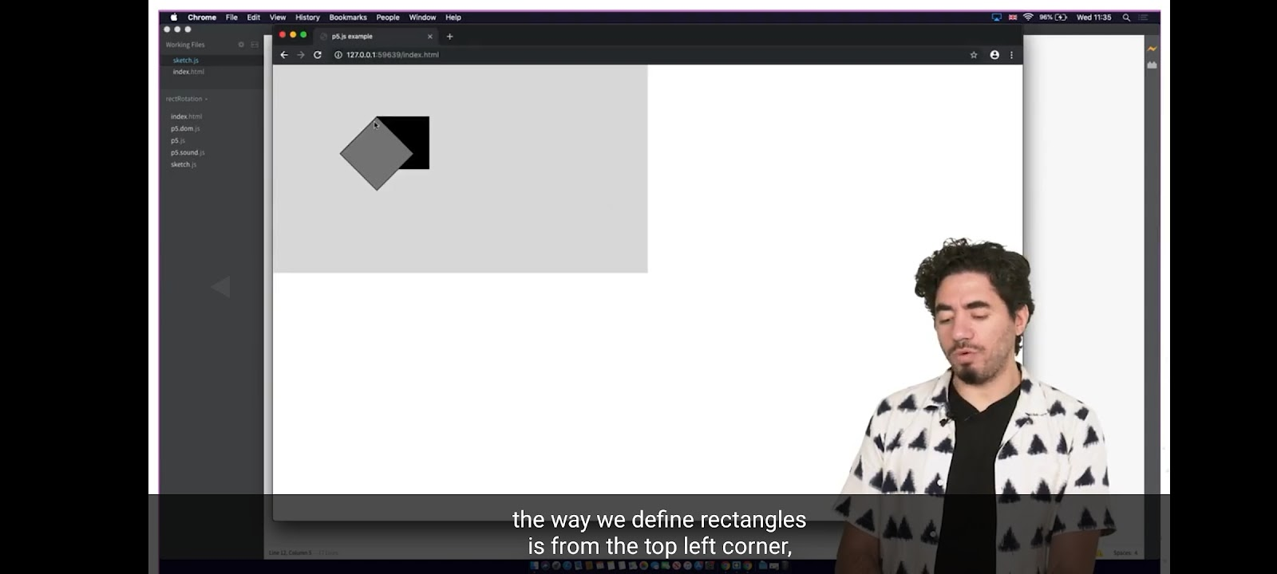

*Answer*

  function draw() {

    fill(0);

    translate(100,100);

    rect(0,0,100,100);

    rotate(radians(45));

    fill(125);

    rect(0,0,100,100);

  }

* Now use rectmode to make that rotation act on the center of the triangle not the top left corner

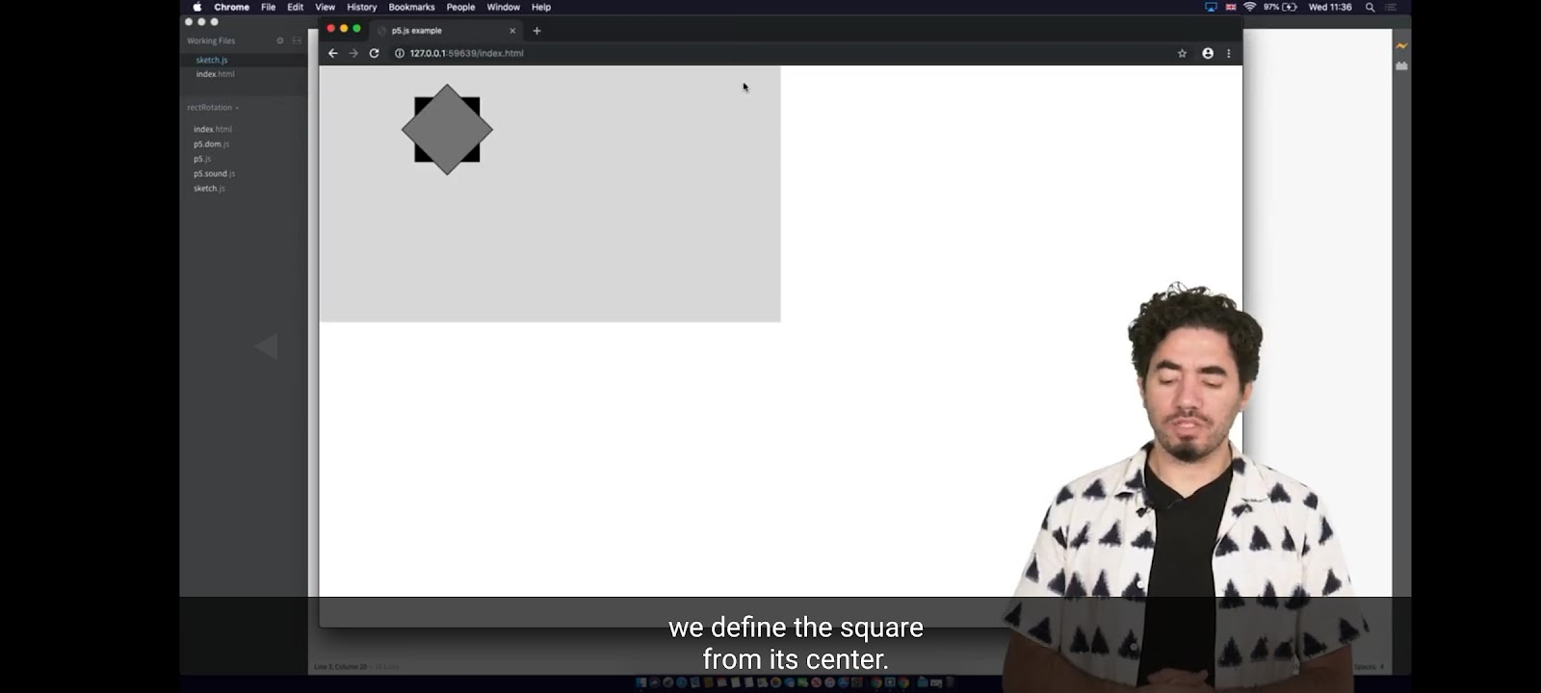

  function draw() {

    fill(0);

    translate(100,100);

    rect(0,0,100,100);

    rotate(radians(45));

    fill(125);

    rect(0,0,100,100);

  }

* Now scale the grey rectangle

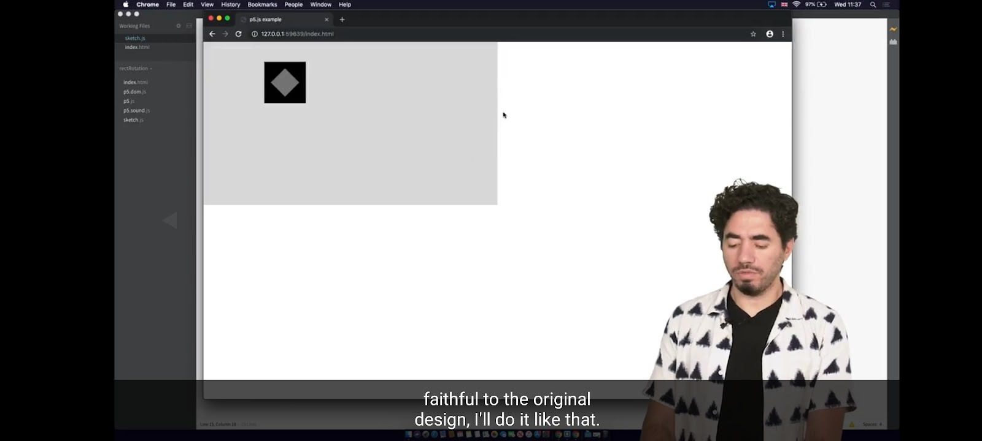

*Answer*

  function draw() {

    rectMode(CENTER);

    fill(0);

    translate(100,100);

    rect(0,0,100,100);

    rotate(radians(45));

    fill(125);

    scale(0.5);

    rect(0,0,100,100);

  }

* Finally remove the rotation

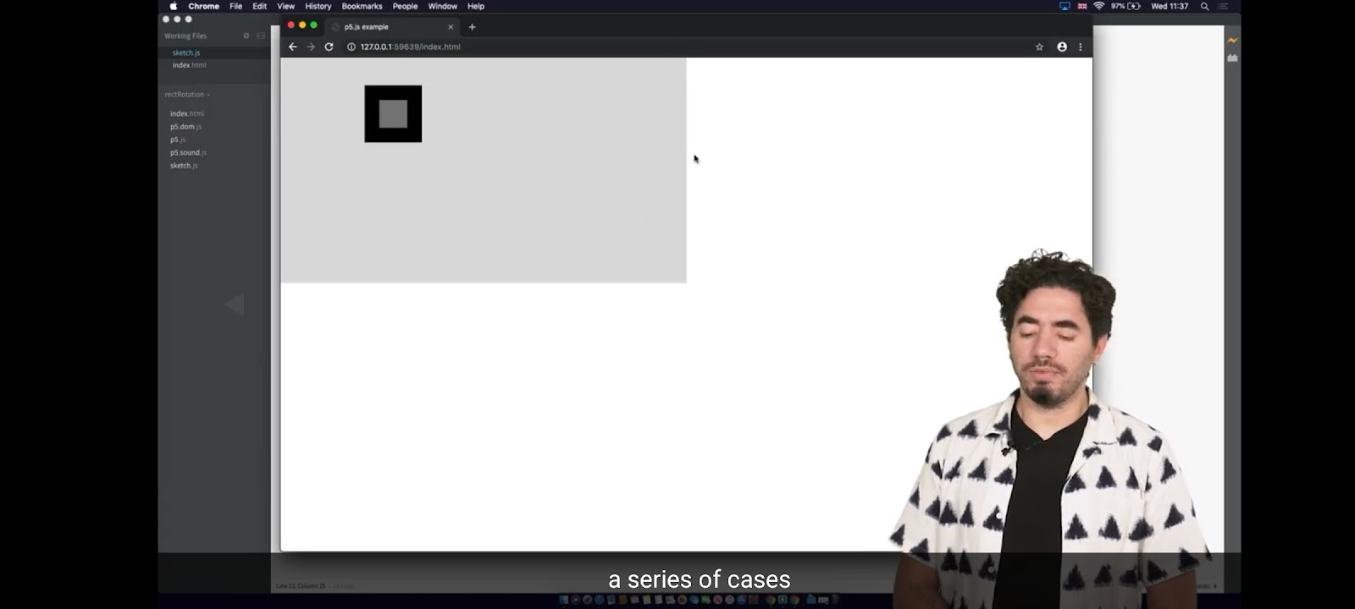

*Answer*

  function draw() {

    rectMode(CENTER);

    fill(0);

    translate(100,100);

    rect(0,0,100,100);

    fill(125);

    scale(0.5);

    rect(0,0,100,100);

  }

* Now create this with the constraint that the ellipses must all be positionned at 0 0. Use push and pop to get back to the initial origin system.

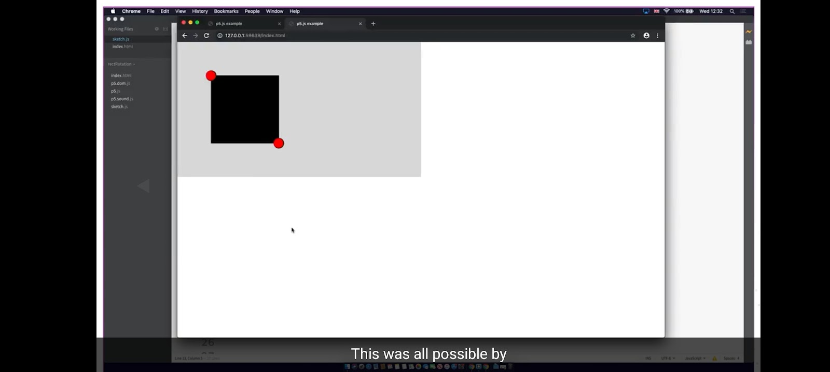

*Answer*

  function draw() {

    background(255,160,122); // Ligh salmon

    fill(0);

    translate(100,100);

    rect(0,0,200,200);

    push();

    translate(200,200); //You translate from the latest translation point. Translation is transitive

    fill(255,0,0);

    ellipse(0,0,20,20);

    pop();

    // Now we are back to the origin before the push

    fill(255,0,0);

    ellipse(0,0,20,20);

  }

Q. What does push and pop allow you to do

* It restrains any styling (like fill) and transformations (like translate and rotate) to the code segment covered by the push and pop

## Drawing a clock

The clock should read the time from the machine and draw it on the screen

* First create an ellipse at the center of the screen . The clock will be at inside that circle
* translate(400,400);
* ellipse(0,0,400,400);
* Create global variables for seconds, minutes and hours. For each define the length and the width. Make lengths from seconds to hours 160, 140, 90. Make width 1,3,5.

var secLength  =  160;

var minLength  =  140;

var hourLength =  90;

var secWidth   =  1;

var minWidth   =  3;

var hourWidth  =  5;

* Code the seconds hand and make it move as the seconds advance.

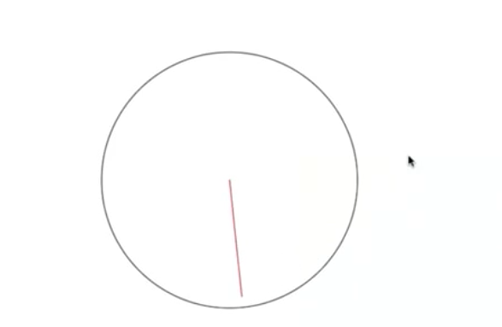

  // seconds hand

    strokeWeight(secWidth);

    var secAngle = map(second(),0,60,0,360);

    push();

    stroke(200,0,0);

    rotate(radians(secAngle));

    line(0,0,0,-secLength);

    pop();

* Repeat the same for the minutes and the hours hand
* // minutes hand
* strokeWeight(minWidth);
* var minAngle = map(minute(),0,60,0,360);
* push();
* rotate(radians(minAngle));
* line(0,0,0,-minLength);
* pop();
* // hours hand
* strokeWeight(hourWidth);
* var hourAngle = map(hour(),0,12,0,360);
* push();
* rotate(radians(hourAngle));
* line(0,0,0,-hourLength);
* pop();
* print(hour());

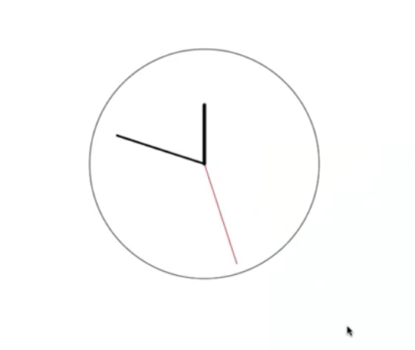

* Now add an ellipse inside the hour handle. Create a push and pop system with the push and pop system of the hour handle to do it

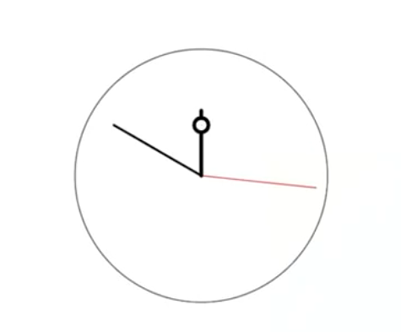

* // hours hand
* strokeWeight(hourWidth);
* var hourAngle = map(hour(),0,12,0,360);
* push();
* rotate(radians(hourAngle));
* line(0,0,0,-hourLength);
* **push();**
* **translate(0, -hourLength + 20);**
* **ellipse(0,0,20,20);**
* **pop();**
* pop();
* print(hour());
* Finally add the little marks for the hours

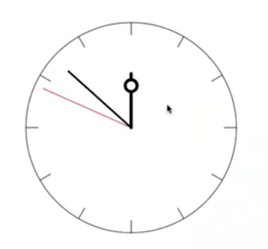

    var tickAngle = 360/12;

    for (var i=0; i<12; i++) {

        push();

        rotate(radians(tickAngle*i));

        translate(0,-circleRadius/2);

        line(0,0,0,20);

        pop();

    }

The ticky part was line(0,0,0,20)

## Graded assignment

Step 1:  Create an earth of color blue and size 80. Move it to orbit 300 pixels. Hint: You should only use transformations to achieve this.

    push();

    translate(0,-300);

    celestialObj(color(0,0,255), 80); // SUN

    pop();

Now : Weeks 1 to 4 are only about the python basics that I know

It becomes interesting from week 5 on

Step 2: Rotate the earth around the sun at velocity "speed". Make sure you use the radians() function inside the rotate() call.

 push();

    translate(width/2, height/2);

    celestialObj(color(255,150,0), 200); // SUN

**push();**

**rotate(radians(speed%360));**

**translate(0,-300);**

**celestialObj(color(0,0,255), 80); // SUN**

**console.log(speed%360);**

**pop();**

    pop();

Step 4: Add a moon of color white and size 30 to the earth at an orbit of 100 pixels. Make the moon rotate at velocity -speed*2 so it spins the opposite way to the way the earth rotates. Make sure that your moon, while spinning around the earth, always shows the same side to earthlings (ie earthlings should not be able to see the so-called 'dark side of the moon').

            // MOON

            push();

                var moonSpeed = -speed*2;

                rotate(radians(moonSpeed%360));

                translate(0,100);

                celestialObj(color(255,255,255), 30);

            pop();

Step 5: Make the sun spin around its axis, as it really does, at a slow speed/3.

 // SUN

    var sunSpeed = speed/3;

    rotate(radians(sunSpeed%360));

    celestialObj(color(255,150,0), 200);

Step 6: Extend the sketch by adding one more celestial body by implementing one of the ideas for further development.

          // Extension: MOON 2

            push();

            var moonSpeed = -speed*4;

            rotate(radians(moonSpeed%360));

            translate(100,100);

            celestialObj(color(255,255,255), 30);

            pop();

**Here is the whole code – In case it gets lost**

var speed;

function setup() {

    createCanvas(1500, 1500);

}

function draw() {

    background(0);

    speed = frameCount;

    push();

    translate(width/2, height/2);

    // SUN

    var sunSpeed = speed/3;

    rotate(radians(sunSpeed%360));

    celestialObj(color(255,150,0), 200);

        // EARTH

        push();

        rotate(radians(speed%360));

        translate(0,-300);

        celestialObj(color(0,0,255), 80);

            // MOON 1

            push();

            var moonSpeed = -speed*2;

            rotate(radians(moonSpeed%360));

            translate(0,100);

            celestialObj(color(255,255,255), 30);

                // Asteroid

                push();

                var asteroidSpeed = 10*speed;

                rotate(radians(asteroidSpeed%360));

                translate(0,30);

                celestialObj(color(180,20,87), 25);

                pop();

            pop();

            // Extension: MOON 2

            push();

            var moonSpeed = -speed*4;

            rotate(radians(moonSpeed%360));

            translate(100,100);

            celestialObj(color(255,255,255), 30);

            pop();

        pop();

    pop();

}

function celestialObj(c, size){

    strokeWeight(5);

    fill(c);

    stroke(0);

    ellipse(0, 0, size, size);

    line(0, 0, size/2, 0);

}

## Object Oriented Programming

In this example we create a button and when we click on it it turns on or off

* Q. Explain metaphorically what a class is in terms or a cookie cutter
  + The class is the cookie cutter
  + Whenever you cut the pate with the cookie cutter you create an instance object of that class
* Q. What does the constructor do in a class ?

When we create an instance object of the class, automatically the constructor() function is called. It initializes the data of that instance with what is inside the constructor

* Q. Inside a class in Javascript you want to define a method draw(). What is the syntax ?
  + A. function draw() {…}
  + B. function this.draw() {…}
  + C. this.draw() {…}
  + D. draw() {…}
    - Answer: D
* Q. Define global variables state (Boolean initialized to false means button is off.), locX and locY (initialized to 200) and width and heigt (w,h) initialized to 200 and 100.
  + q
* Q. List the advantages of OOP
  + Maintainability: To change objects belonging to a class you only have to change the line of the code in the class, not in all objects
  + Makes code more compact: You do not repeat the same code for each object
  + Transfer: You can give the code to a friend and he will create a class
* Q. The arguments of an object that vary from an object to another are passed to the class or the constructor ?
  + To the constructor
* Q. Create this: A black rectangle. When you click on it it turns white . DO not use OOP at this point

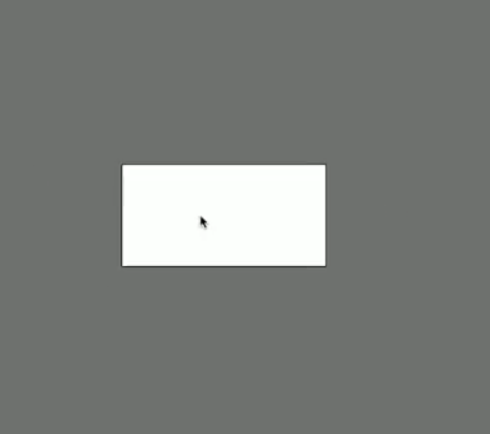

function draw() {

    background(125);

    if (state) {

        fill(255);

    }

    else {

        fill(0);

    }

    rect(locX, locY, w, h);

}

function mousePressed() {

    if (mouseX > locX && mouseX < (locX+w) && mouseY > locY && mouseY < (locY+h)) {

        state = !state;

    }

}

* Q. Now move all the logic of the button inside a button class
* var button1;
* function setup() {
* createCanvas(1500, 1500);
* background(0);
* button1 = new Button();
* }
* function draw() {
* background(125);
* button1.draw();
* }
* function mousePressed() {
* button1.flick(mouseX, mouseY);
* }
* class Button {
* constructor() {
* this.state = false;
* this.locX = 200;
* this.locY = 200;
* this.w = 200;
* this.h = 100;
* }
* draw() {
* if (this.state) {
* fill(255);
* }
* else {
* fill(0);
* }
* rect(this.locX, this.locY, this.w, this.h);
* }
* flick(x,y) {
* if (x > this.locX && x < (this.locX+this.w) && y > this.locY && y < (this.locY+this.h)) {
* this.state = !this.state;
* }
* }
* }
* Q. in this.locX = locX what is this.locX and what is locX ?
  + locX is the global variable locX
  + this.locX is
* Q. Now allow the user to create new buttons with the location and width/height that he wants like this

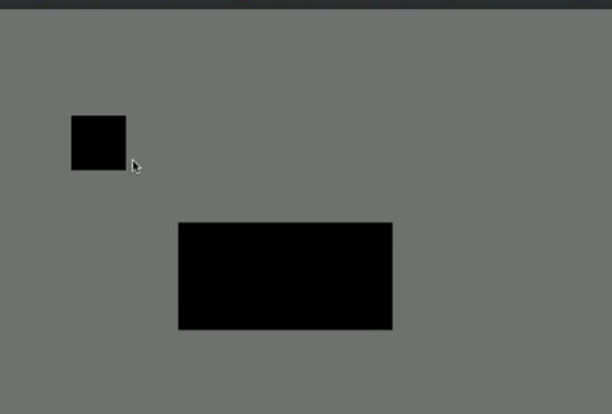

Here the key point is that you pass the arguments to the constructor, not the class

class Button {

    constructor(x, y, w, h) {

        this.state = false;

        this.locX = x;

        this.locY = y;

        this.w = w;

        this.h = h;

    }

button1 = new Button(200,200,200,100);

button2 = new Button(100,100,50,50);

function draw() {

    background(125);

    button1.draw();

    button2.draw();

}

function mousePressed() {

    button1.flick(mouseX, mouseY);

    button2.flick(mouseX, mouseY);

}

# Week 2: Acceleration

## 1_Using Vectors

Here we code a simple bouncing ball, with and without vectors

Q. [Version without vector]Create a ball object. Use a class. Give it location and speed (random between -2 and 2) attributes and make those random . Draw it to the screen and make it move. Have one method for draw and one method for run. Have a method run that calls the two methods draw and move. Make it bounce as it touches the border of the screen

var ball;

function setup() {

    createCanvas(900, 600);

    background(0);

    ball = new Ball();

}

function draw() {

    background(0); // this one is important to eease the previoius ball as it moves

    ball.run();

    }

class Ball {

    constructor() {

        this.locationX = random(width);

        this.locationY = random(height);

        this.speedX = random(-2,2);

        this.speedY = random(-2,2);

    }

    run() {

        this.draw();

        this.move();

        this.bounce();

    }

    draw() {

        fill(125);

        ellipse(this.locationX, this.locationY, 30)

    }

    move() {

        this.locationX += this.speedX;

        this.locationY += this.speedY;

    }

    bounce() {

        if (this.locationX < 0 || this.locationX > width) this.speedX *= -1;

        if (this.locationY < 0 || this.locationY > height) this.speedY *= -1;

    }

}

Q. [Version with vector]Now notice that there are two many variables. Use vectors to make your code more tidy. Note that we use vectors to build more complex systems using a higher level of abstraction. Use the createVector() command. Remember to use **incrememental development** ie check your code steo by step

- How do you add all the components of one vector ?

Use the p5 reference

<https://p5js.org/reference/#/p5/createVector>

https://p5js.org/reference/#/p5/createVector

Here is the code. It is much cleaner

var ball;

function setup() {

    createCanvas(900, 600);

    background(0);

    ball = new Ball();

}

function draw() {

    background(0); // this one is important to eease the previoius ball as it moves

    ball.run();

    }

class Ball {

    constructor() {

        this.location = createVector(random(width), random(height));

        this.speed = createVector(random(-2,2), random(-2,2));

    }

    run() {

        this.draw();

        this.move();

        this.bounce();

    }

    draw() {

        fill(125);

        ellipse(this.location.x, this.location.y, 30)

    }

    move() {

        this.location.add(this.speed);

    }

    bounce() {

        if (this.location.x < 0 || this.location.x > width) this.speed.x *= -1;

        if (this.location.y < 0 || this.location.y > height) this.speed.y *= -1;

    }

}

Next step: do graded quiz

## 1_Vector_Substraction

Q. Use vector substraction to draw a line that goes from the center of the screen to the location of the mouse

function draw() {

    background(125);

    var myMouse = createVector(mouseX, mouseY);

    var center = createVector(width/2,height/2);

    myMouse.sub(center);

    translate(width/2, height/2);

    ellipse(0,0,5,5);

    strokeWeight(3);

    fill(255);

    console.log(myMouse);

    line(0,0,myMouse.x, myMouse.y);

}

## 3_Vector_Scaling

In the previous example if you want to divide the size of the line by 2

Mouse.mult(0.5);

Mouse.dic(2)

## 4_calculating magnitude and normalizing

mouse.mag() in the example above prints the magnitude of the vector

mouse.normalize() builds the normalized vector

use mouse.copy() to create a copy of the mouse

## 5_Acceleration 101

The point of this section is to simplify the bouncing ball example so that we only define the acceleration of the ball. We do not need to define the position of the ball at every frame

* Q. Amend the move() function in the bouncing ball example, so that when the ball reaches an edge, it reappears on the opposite edge
* edges() {
* if (this.location.x < 0) this.location.x = width;
* else if (this.location.x > width) this.location.x = 0;
* else if (this.location.y < 0) this.location.y = height;
* else if (this.location.y > height) this.location.y = 0;
* }
* Q. Now starting from the middle left corner of the screen, make the ball accelerate according to a constant acceleration. Make the ball move only across the x-axis. Add a limit to the speed

Use documentation for limit

<https://p5js.org/reference/#/p5.Vector/limit>

var ball;

function setup() {

    createCanvas(900, 600);

    background(0);

    ball = new Ball();

}

function draw() {

    background(0); // this one is important to eease the previoius ball as it moves

    ball.run();

    }

class Ball {

    constructor() {

        this.location = createVector(0, height/2);

        this.speed = createVector(0, 0);

        this.acceleration = createVector(0.03);

    }

    run() {

        this.draw();

        this.move();

        this.edges();

    }

    draw() {

        fill(125);

        ellipse(this.location.x, this.location.y, 30);

        this.speed.limit(10); // limits the magnitude of the vector

        console.log(this.speed.x);

    }

    move() {

        this.speed.add(this.acceleration);

        this.location.add(this.speed);

    }

    edges() {

        if (this.location.x < 0) this.location.x = width;

        else if (this.location.x > width) this.location.x = 0;

        else if (this.location.y < 0) this.location.y = height;

        else if (this.location.y > height) this.location.y = 0;

    }

}

## 6_ Follow the mouse

* Q. What are static functions ? How does the output of the static function differ from that of class methds ?
* Static functions are called from the class itself, not from an instance of the class. As in p5.Vector.add(v1,v2)
* Static function return a new object of the class v3 and therefore does not change the objects v1 and v2
  + This is unlike doing v1.add(v2) which change v1
* Q. now take the bouncing ball code with acceleration. Make the ball basically follow the mouse, as if it was its center of gravity
* var ball;
* function setup() {
* createCanvas(900, 600);
* background(0);
* ball = new Ball();
* }
* function draw() {
* background(0); // this one is important to eease the previoius ball as it moves
* ball.run();
* }
* class Ball {
* constructor() {
* this.location = createVector(0, height/2);
* this.speed = createVector(0, 0);
* this.acceleration = createVector(0);
* }
* run() {
* this.draw();
* this.move();
* this.edges();
* }
* draw() {
* fill(125);
* ellipse(this.location.x, this.location.y, 30);
* this.speed.limit(5); // limits the magnitude of the speed
* }
* move() {
* this.speed.add(this.acceleration);
* this.location.add(this.speed);
* // Creating a normalized vector of direction from the ball pointing to the mouse
* var mouse = createVector(mouseX, mouseY);
* var gravity = p5.Vector.sub(mouse, this.location);
* gravity.normalize();
* gravity.mult(0.3);
* console.log(gravity.x);
* this.acceleration = gravity;
* }
* edges() {
* if (this.location.x < 0) this.location.x = width;
* else if (this.location.x > width) this.location.x = 0;
* else if (this.location.y < 0) this.location.y = height;
* else if (this.location.y > height) this.location.y = 0;
* }
* }

Q. Now modify the code to trace the path that the ball follows as a line

var ball;

function setup() {

    createCanvas(900, 600);

    background(0);

    ball = new Ball();

}

function draw() {

    ball.run();

    }

class Ball {

    constructor() {

        this.location = createVector(width/2, height/2);

        this.previousLocation = createVector(width/2, height/2);

        this.speed = createVector(0, 0);

        this.acceleration = createVector(0);

    }

    run() {

        this.draw();

        this.move();

        this.edges();

    }

    draw() {

        stroke(125);

        strokeWeight(3);

        // ellipse(this.location.x, this.location.y, 30);

        this.speed.limit(5); // limits the magnitude of the speed

        line(this.location.x, this.location.y, this.previousLocation.x, this.previousLocation.y);

        this.previousLocation = this.location.copy();

    }

    move() {

        this.speed.add(this.acceleration);

        this.location.add(this.speed);

        // Creating a normalized vector of direction from the ball pointing to the mouse

        var mouse = createVector(mouseX, mouseY);

        var gravity = p5.Vector.sub(mouse, this.location);

        gravity.normalize();

        gravity.mult(0.3);

        // Make acceleration equal to gravity

        this.acceleration = gravity;

    }

    edges() {

        if (this.location.x < 0) this.location.x = width;

        else if (this.location.x > width) this.location.x = 0;

        else if (this.location.y < 0) this.location.y = height;

        else if (this.location.y > height) this.location.y = 0;

    }

}

## 7_ Hack it: Mouse patterns

# Week 3 : Forces and collision detection

## 1_Introduction to forces

F=ma

After setting m=1 you get F=a

So when an object has some vector acceleration and you apply a force to it, the acceleration can be changed via this function

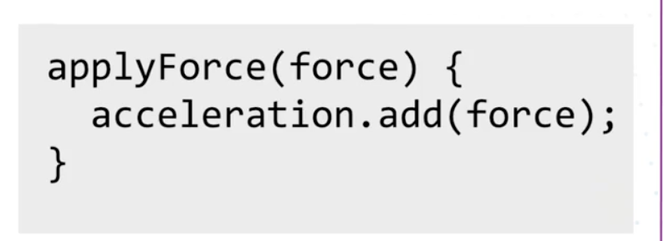

Which allows us to apply any force

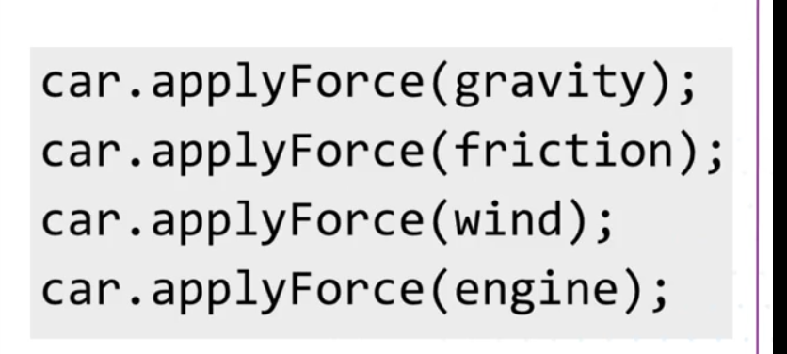

## 2_Force accumulation

Q. Starting from the bouncing ball example with no mouse, rebuild the mouse attraction, but this time applying the applyForce() method above

Here is the code. At each draw, the acceleration dir vector is reset, therefore you must multiply acceleration by 0 at the end of the move() method to reset that vector. Otherwise the acceleration vectors will accumulate

var ball;

function setup() {

    createCanvas(900, 600);

    background(0);

    ball = new Ball();

}

function draw() {

    background(0); // this one is important to eease the previoius ball as it moves

    ball.run();

    var mouse = createVector(mouseX, mouseY);

    var dir = mouse.sub(ball.location);

    dir.normalize();

    dir.mult(0.3);

    ball.applyForce(dir);

    console.log(dir.x);

    }

class Ball {

    constructor() {

        this.location = createVector(width/2, height/2);

        this.speed = createVector(0, 0);

        this.acceleration = createVector(0,0);

    }

    run() {

        this.draw();

        this.move();

        this.edges();

    }

    draw() {

        fill(125);

        ellipse(this.location.x, this.location.y, 30);

        this.speed.limit(10); // limits the magnitude of the speed

    }

    move() {

        this.speed.add(this.acceleration);

        this.location.add(this.speed);

        this.acceleration.mult(0);

    }

    edges() {

        if (this.location.x < 0) this.location.x = width;

        else if (this.location.x > width) this.location.x = 0;

        else if (this.location.y < 0) this.location.y = height;

        else if (this.location.y > height) this.location.y = 0;

    }

    applyForce(force) {

        this.acceleration.add(force);

    }

}

## 3_Coding Gravity

*Q. Remove the mouse effect and add a gravity effect to the ball, by which the ball bounces down.*

function draw() {

    background(0); // this one is important to eease the previoius ball as it moves

    var gravity = createVector(0, 0.1);

    ball.applyForce(gravity);

    ball.run();

    }

The rest is the same as a above

So the whole code is like this

var ball;

function setup() {

    createCanvas(900, 600);

    background(0);

    ball = new Ball();

}

function draw() {

    background(0); // this one is important to eease the previoius ball as it moves

    var gravity = createVector(0, 0.1);

    ball.applyForce(gravity);

    ball.run();

    }

class Ball {

    constructor() {

        this.location = createVector(width/2, height/2);

        this.speed = createVector(0, 0);

        this.acceleration = createVector(0,0);

    }

    run() {

        this.draw();

        this.move();

        this.edges();

    }

    draw() {

        fill(125);

        ellipse(this.location.x, this.location.y, 30);

        this.speed.limit(10); // limits the magnitude of the speed

    }

    move() {

        this.speed.add(this.acceleration);

        this.location.add(this.speed);

        this.acceleration.mult(0);

    }

    edges() {

        if (this.location.x < 0 || this.location.x > width || this.location.y < 0 ||this.location.y > height ) {

            this.speed.mult(-1);

        }

    }

    applyForce(force) {

        this.acceleration.add(force);

    }

}

*Q. The problem is that the ball keeps coming back to the screen. Now add some friction to the ball so that the rebound fades with time. Compute friction as minus velocity, multiplied by some factor*

For some reason he makes friction a force equal to -speed, which I believe is wrong from a physics standpoint

var ball;

function setup() {

    createCanvas(900, 600);

    background(0);

    ball = new Ball();

}

function draw() {

    background(0); // this one is important to ease the previous ball as it moves

    var gravity = createVector(0, 0.1);

    ball.applyForce(gravity);

    ball.run();

    }

class Ball {

    constructor() {

        this.location = createVector(width/2, height/2);

        this.speed = createVector(0, 0);

        this.acceleration = createVector(0,0);

    }

    run() {

        this.draw();

        this.move();

        this.edges();

    }

    draw() {

        fill(125);

        ellipse(this.location.x, this.location.y, 30);

        this.speed.limit(10); // limits the magnitude of the speed

    }

    move() {

        this.speed.add(this.acceleration);

        this.location.add(this.speed);

        this.acceleration.mult(0);

        var friction = this.speed.copy();

        friction.normalize();

        friction.mult(-0.01);

        this.applyForce(friction);

    }

    edges() {

        if (this.location.x < 0 || this.location.x > width || this.location.y < 0 ||this.location.y > height ) {

            this.speed.mult(-1);

        }

    }

    applyForce(force) {

        this.acceleration.add(force);

    }

}

## 4_Hack it Patrticles

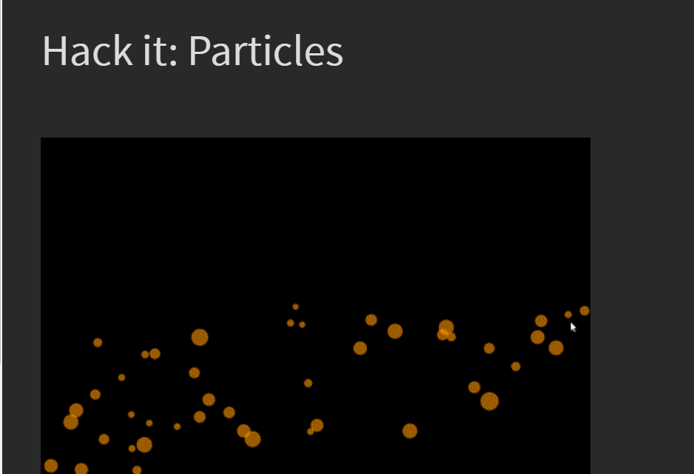

In this example you'll code particles that fall when the mouse is dragged and bounce on the ground as in the image above.

Steps to complete

Step 1: Start from the **forceAccumulation** provided in this week's examples. Rename the ball variable to a balls and initialise it as an empty array.

Step 2: Create a for loop inside the draw() function and loop over all balls. Within the loop execute all code that would be previously applied to a single ball. Remember, balls is now an array eventually containing many balls. (Hint: Use the length property of the array to loop over it and an index to access a specific ball in the array.)

Step 3: Create a mouseDragged() function and write within it:

balls.push(new Ball(mouseX, mouseY));

in order to push a new ball to the array every time the mouse is dragged. We’re not done yet! Notice that the call to create a new ball passes the location of the mouse to the constructor.

Step 4: Modify the constructor of the Ball class in order to take two parameters, x and y. Use these to initialise the location vector in the constructor. If you’ve done things right, as you drag the mouse you should see many balls being generated and flying off in the same direction.

Step 5: In the constructor set the initial values of velocity to be random from -3 to 3 for both x and y components. Set the size to also be random. If you’ve done things right, as you drag the mouse you should see many particles of various sizes being initialised.

Ideas for further development

* experiment with different colors.
* add a variable age in the ball class. When a ball is initialised have it be equal to 255. In every loop reduce it by 1 and use age as a transparency for the color of the particle.
* experiment with different levels of friction.
* create a function buttonPressed() that clears the array when a button is pressed.

Here is the code

//////////////////////////////////

// COURSERA GRAPHICS PROGRAMMING

//////////////////////////////////

// Adapted from https://github.com/nature-of-code/

// released under MIT license

var ball;

////////////////////////////////////////////////////

function setup() {

  createCanvas(900, 600);

  balls = [];

}

function mouseDragged() {

  balls.push(new Ball(mouseX, mouseY));

}

////////////////////////////////////////////////////

function draw() {

  background(0);

  // Gravity -- common to all balls

  var gravity = createVector(0, 0.1);

  // Ball movement

  for (var i=0; i< balls.length; i++) {

    // Apply gravity

    balls[i].applyForce(gravity);

    // Apply friction

    var friction = balls[i].velocity.copy();

    friction.mult(-1);

    friction.normalize();

    friction.mult(0.01);

    balls[i].applyForce(friction);

    // Make ball move

    balls[i].run();

  }

}

//////////////////////////////////////////////////////

class Ball {

  constructor(x,y){

    this.velocity = new createVector(random(-3,3), random(-3,3));

    this.location = new createVector(x, y);

    this.acceleration = new createVector(0, 0);

    this.size = random(10,40);

  }

  run(){

    this.draw();

    this.move();

    this.bounce();

  }

  draw(){

    fill(255,165,0,100);

    ellipse(this.location.x, this.location.y, this.size, this.size);

  }

  move(){

    this.velocity.add(this.acceleration);

    this.location.add(this.velocity);

    this.acceleration.mult(0);

  }

  bounce(){

    if (this.location.x > width-this.size/2) {

          this.location.x = width-this.size/2;

          this.velocity.x *= -1;

    } else if (this.location.x < this.size/2) {

          this.velocity.x *= -1;

          this.location.x = this.size/2;

    }

    if (this.location.y > height-this.size/2) {

          this.velocity.y *= -1;

          this.location.y = height-this.size/2;

    }

  }

  applyForce(force){

    this.acceleration.add(force);

  }

}

## 5_Introducing collision detection

To check if a points collides with a circle you check if the distance between the point and the center of the circle is lower or higher than the radius

To check if two circle collide you check if the distance between the centers is lower or higher than the sum of the radiuses

A strategy used is quadrees where you segment the 2D space into compartments and use your collision detection algorithm inside each compartment only

Bounding boxes are an attempt to simplify the comparisons between shapes. Rather than going through all the vertices of complex shapes to see if there’s overlap, we can use a simplified shape (known as a bounding box) to check for overlaps instead.

Quadtrees and uniform grids are two examples of spatial partitioning algorithms. For example, in the case of collision detection, they can be used to minimise the number of overlap tests done between bounding boxes. Instead of having to potentially compare all objects with all other objects in the scene, which quickly gets inefficient when more objects are added, we can group the objects into spatial zones which allows for more efficient comparisons. This is a large topic in computation so ensuring that you understand the broad concepts of the quadtree example in the video will prepare you for your next encounter with spatial partitioning algorithms.

## 6_Hack it: Particles with collision detection

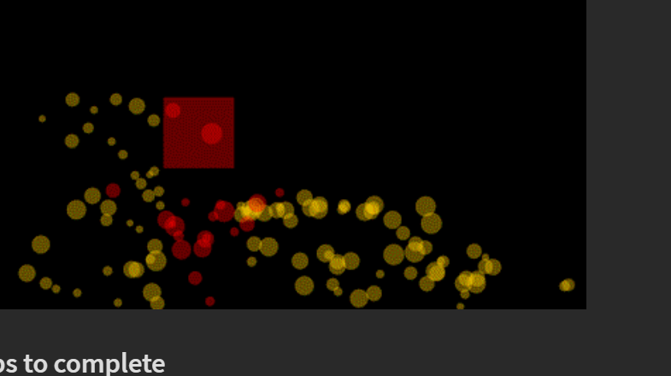

## Steps to complete

Modify the code from the previous coding exercise to include a box in the middle of the canvas. When particles pass through that box they should change color and become red. You'll need to use what you learned about collision detection between a circle and a square to do this.

I did it ! The hardest part is making the color last after the ball gets out of the square. The solution is to create a state variable hasCollided that dictates the color

 draw(){

    if(this.location.x > square.x && this.location.x < square.x + square.width && this.location.y > square.y  && this.location.y < square.y + square.height ) {

      this.hasCollided = true;

    }

    if(this.hasCollided) {

      fill(0,255,0);

    }

    else {

      fill(255,165,0,100);

    }

    ellipse(this.location.x, this.location.y, this.size, this.size);

  }

Here is the whole code

//////////////////////////////////

// COURSERA GRAPHICS PROGRAMMING

//////////////////////////////////

// Adapted from https://github.com/nature-of-code/

// released under MIT license

var ball;

var square;

var hasCollided;

////////////////////////////////////////////////////

function setup() {

  createCanvas(900, 600);

  balls = [];

  square = {

    x: 400,

    y: 250,

    width: 150,

    height:150

  }

}

function mouseDragged() {

  balls.push(new Ball(mouseX, mouseY));

}

////////////////////////////////////////////////////

function draw() {

  background(0);

  // Draw box in the middle of the canvas

  fill(255,0,0,100);

  rect(square.x,square.y,square.width,square.height);

  // Gravity -- common to all balls

  var gravity = createVector(0, 0.1);

  // Ball movement

  for (var i=0; i< balls.length; i++) {

    // Apply gravity

    balls[i].applyForce(gravity);

    // Apply friction

    var friction = balls[i].velocity.copy();

    friction.mult(-1);

    friction.normalize();

    friction.mult(0.01);

    balls[i].applyForce(friction);

    // Make ball move

    balls[i].run();

  }

}

//////////////////////////////////////////////////////

class Ball {

  constructor(x,y){

    this.hasCollided = false;

    this.velocity = new createVector(random(-3,3), random(-3,3));

    this.location = new createVector(x, y);

    this.acceleration = new createVector(0, 0);

    this.size = random(10,40);

  }

  run(){

    this.draw();

    this.move();

    this.bounce();

  }

  draw(){

    if(this.location.x > square.x && this.location.x < square.x + square.width && this.location.y > square.y  && this.location.y < square.y + square.height ) {

      this.hasCollided = true;

    }

    if(this.hasCollided) {

      fill(0,255,0);

    }

    else {

      fill(255,165,0,100);

    }

    ellipse(this.location.x, this.location.y, this.size, this.size);

  }

  move(){

    this.velocity.add(this.acceleration);

    this.location.add(this.velocity);

    this.acceleration.mult(0);

  }

  bounce(){

    if (this.location.x > width-this.size/2) {

          this.location.x = width-this.size/2;

          this.velocity.x *= -1;

    } else if (this.location.x < this.size/2) {

          this.velocity.x *= -1;

          this.location.x = this.size/2;

    }

    if (this.location.y > height-this.size/2) {

          this.velocity.y *= -1;

          this.location.y = height-this.size/2;

    }

  }

  applyForce(force){

    this.acceleration.add(force);

  }

}

## 6_Graded assignment Asteroid game clone

# Week 4: Bodies and Constraints

## 1_ Introduction to matter.js

Matter.js is a Physics ngine. A Physics engine takes numbers ad inputs and produces outputs derived from physic calculations. It is still p5.js that does all the drawing

There are many other physics engines

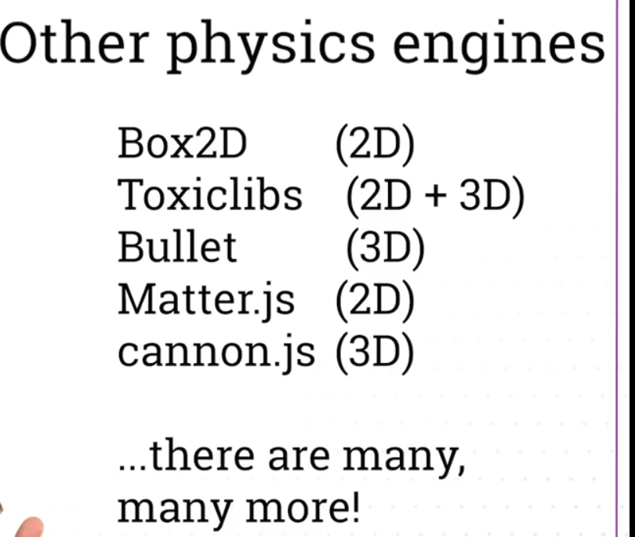

* Box2D was started in C++, then extended to Java and Javascript. It is very used professionally
* Matter.js was developed in javascript from scratch with the web in mind. It is good for what we need: Collisions and connected systems such as springs

## 3_ Basic elements of matter.js

Documentation

<https://brm.io/matter-js/docs/>

Click on getting started

Here is the first version of the code

// module aliases -- nicknames that make the command shorter

var Engine = Matter.Engine;

var Render = Matter.Render;

var World = Matter.World;

var Bodies = Matter.Bodies;

// Global variables

var engine;

var box1; // A body that we will create

var ground; // a ground for the ball to bounce on

function setup() {

    createCanvas(900,600);

    // create en engine

    engine = Engine.create();

    // we create our first body and the ground

        // box is falling with gravity. Restitution is the energy with which it bounces

    box1 = Bodies.rectangle(200,200,80,80, {restitution:0.8, friction: 0.5});

        // ground is not falling

    var options = {isStatic: true, angle: Math.PI * 0.06};

    ground = Bodies.rectangle(400,500,810,10, options);

    // We add all the bodies to the word

    World.add(engine.world, [box1, ground]);

}

function draw() {

    // Update the engine at each loop of the draw() function

    background(0);

    Engine.update(engine);

    // Draw the object

    rectMode(CENTER); // matter.js defines objects from the center

    push();

    fill(255);

    var pos = box1.position // vector of positions

    translate(pos.x, pos.y);

    rotate(box1.angle);

    rect(0,0,80,80);// attention must have sam dimension as in creation

    pop(); // Note that the object drops because there is default gravity

    // Draw the ground

    push();

    fill(255);

    var groundpos = ground.position // vector of positions

    translate(groundpos.x, groundpos.y);

    rotate(ground.angle);

    rect(0,0,810,10); // attention must have sam dimension as in creation

    pop(); // Note that the object drops because there is default gravity

}

Now we can optimize the drawing part this way

## 4_ Adding Other types of bodies

The different types of bodies that you can have are listed here

<https://brm.io/matter-js/docs/classes/Bodies.html>

// module aliases -- nicknames that make the command shorter

var Engine = Matter.Engine;

var Render = Matter.Render;

var World = Matter.World;

var Bodies = Matter.Bodies;

// Global variables

var engine;

var box1; // A body that we will create

var ground1, ground2; // a ground for the ball to bounce on

var circle, polygon; // trying other objects

function setup() {

    createCanvas(900,600);

    // create en engine

    engine = Engine.create();

    // we create our first body and the ground

        // box is falling with gravity. Restitution is the energy with which it bounces

    box1 = Bodies.rectangle(200,200,80,80, {restitution:0.8, friction: 0.5});

    circle = Bodies.circle(80,0,20, {restitution:0.8, friction: 0.5});

    polygon = Bodies.polygon(100, 0, 5, 30, {restitution:0.8, friction: 0.5}); // 5 sides, redius 30

    // ground is not falling

    ground1 = Bodies.rectangle(100,200,500,10, {isStatic: true, angle: Math.PI * 0.06});

    ground2 = Bodies.rectangle(500,500,500,10, {isStatic: true, angle: Math.PI * -0.06});

    // We add all the bodies to the word

    World.add(engine.world, [box1, ground1, ground2, circle, polygon]);

}

function draw() {

    // Update the engine at each loop of the draw() function

    background(0);

    Engine.update(engine);

    // Draw the object

    fill(255);

    drawVertices(box1.vertices);

    drawVertices(circle.vertices);

    drawVertices(polygon.vertices);

    // Draw the grounds

    fill(125);

    drawVertices(ground1.vertices);

    drawVertices(ground2.vertices);

}

function drawVertices(vertices) {

    beginShape();

    for (var i=0; i<vertices.length; i++) {

        vertex(vertices[i].x, vertices[i].y);

    }

    endShape(CLOSE);

}

## 5_ Adding and deleting multiple bodies

Here what we do is

* We create an array to store boxes
* We create a function that generates boxes. We call it from the draw function
* We check if they exist in the scene. If not, we remove them from the box list and from the physics engine

// module aliases -- nicknames that make the command shorter

var Engine = Matter.Engine;

var Render = Matter.Render;

var World = Matter.World;

var Bodies = Matter.Bodies;

// Global variables

var engine;

var box1; // A body that we will create

var ground1, ground2; // a ground for the ball to bounce on

var boxes = [];

function setup() {

    createCanvas(900,600);

    // create en engine

    engine = Engine.create();

    // we create our first body and the ground

        // box is falling with gravity. Restitution is the energy with which it bounces

    box1 = Bodies.rectangle(50,0,50,50, {restitution:0.8, friction: 0.5});

    // ground is not falling

    ground1 = Bodies.rectangle(100,200,500,10, {isStatic: true, angle: Math.PI * 0.06});

    ground2 = Bodies.rectangle(500,500,500,10, {isStatic: true, angle: Math.PI * -0.06});

    // We add all the bodies to the word

    World.add(engine.world, [box1, ground1, ground2]);

}

function draw() {

    // Update the engine at each loop of the draw() function

    background(0);

    Engine.update(engine);

    // Draw the object . Check in console engine.world.bodies

    fill(255);

    drawVertices(box1.vertices);

    generateObject(width/2, 0);

    for (var i=0; i<boxes.length; i++) {

        drawVertices(boxes[i].vertices);

        if (isOffScreen(boxes[i])) {

            // Remove box from physics engine

            World.remove(engine.world, boxes[i]);

            //  Remove box from drawing. Chck in console boxes.length

            boxes.splice(i,1);

            // the next box will not be checked because it is moved one position down and the iterator moves one position up

            //So we need to reexecute the code at i beforemoving to i+1

            // We achieve this this way

            i--;

        }

        //

    }

    // Draw the grounds

    fill(125);

    drawVertices(ground1.vertices);

    drawVertices(ground2.vertices);

}

// Function that generates objects at position x and y

function generateObject(x,y) {

    var b = Bodies.rectangle(x,y, random(10,30), random(10,30), {restitution: 0.8, friction: 0.5})

    boxes.push(b);

    // Tells the physics engine to keep calculating the object position

    World.add(engine.world,[b]);

}

// Function that eliminates objects When off screen

// Which will prevent then physics engine from slowing down

function isOffScreen(body) {

    // returns true if y position > height

    var pos = body.position;

    return (pos.y>height || pos.x <0 || pos.x >width);

}

function drawVertices(vertices) {

    beginShape();

    for (var i=0; i<vertices.length; i++) {

        vertex(vertices[i].x, vertices[i].y);

    }

    endShape(CLOSE);

}

## 6_ Introducing constrains

This has demo on constraints

<https://brm.io/matter-js/demo/#constraints>

If you click on the curly brackets, you get to the github code

We create three systems

* Two bodies constrained together
* One body constrained to a fixed point
* On e body constrained to a fixed point with an elastic join

// Matter.js objects

var Engine = Matter.Engine;

var Render = Matter.Render;

var World = Matter.World;

var Bodies = Matter.Bodies;

var Constraint = Matter.Constraint;

// Global variables

var engine;

var ground; // a ground for the ball to bounce on

// System 1 - Two bodies constrained together

var poly1A;

var poly1B;

var constraint1;

// System 2 - One body constrained to a fixed point

var poly2;

var constraint2;

// System 3

var poly3;

var constraint3;

function setup() {

    createCanvas(900,600);

    // create en engine

    engine = Engine.create();

    // ground

    ground = Bodies.rectangle(width/2,height-20,800,10, {isStatic: true, angle: 0});

    World.add(engine.world, [ground]);

    // System 1: Two bodies constrained together

    poly1A = Bodies.polygon(700,100,6,20);

    poly1B = Bodies.polygon(700,250,1,50);

    constraint1 = Constraint.create({

        bodyA: poly1A,

        point1A: {x:0, y:0}, //grab from its center

        bodyB: poly1B,

        pointB: {x:-10, y:-10}, //Coordinates relative to the center

        stiffness:0.01 // Makes the join elastic

    })

    World.add(engine.world, [poly1A, poly1B, constraint1]);

    // System 2: A body constrained by a fixed point

    poly2 = Bodies.polygon(300,200,5,40);

    constraint2 = Constraint.create({

        // No bodyA. We want poly2 to be attached to a fixed point in the world

        pointA: {x:150, y:50}, //Coordinates of the point

        bodyB: poly2,

        pointB: {x:-10, y:-20}, //Coordinates relative to the center

        stiffness:0.01 // Makes the join elastic

    })

    World.add(engine.world, [poly2, constraint2]);

    // System 3: A body constrained by a fixed point more elastically

    poly3 = Bodies.polygon(400,100,4,30);

    constraint3 = Constraint.create({

        // No bodyA. We want poly2 to be attached to a fixed point in the world

        pointA: {x:400, y:120}, //grab from its center

        bodyB: poly3,

        pointB: {x:-10, y:-20}, //Coordinates relative to the center

        stiffness:0.001, // Makes the join elastic

        damping: 0.05

    })

    World.add(engine.world, [poly3, constraint3]);

}

function draw() {

    // Update the engine at each loop of the draw() function

    background(0);

    Engine.update(engine);

    // Drawing the constraint

    stroke(128);

    strokeWeight(3);

    drawConstraint(constraint1);

    drawConstraint(constraint2);

    drawConstraint(constraint3);

    // Draw the grounds

    strokeWeight(1);

    drawVertices(ground.vertices);

    drawVertices(poly1A.vertices);

    drawVertices(poly1B.vertices);

    drawVertices(poly2.vertices);

    drawVertices(poly3.vertices);

}

// ***********HELPER FUNCTIONS *************//

function drawConstraint(constraint) {

    var offsetA = constraint.pointA;

    var posA = {x:0, y:0};

    if (constraint.bodyA) {

      posA = constraint.bodyA.position;

    }

    var offsetB = constraint.pointB;

    var posB = {x:0, y:0};

    if (constraint.bodyB) {

      posB = constraint.bodyB.position;

    }

    line(

      posA.x + offsetA.x,

      posA.y + offsetA.y,

      posB.x + offsetB.x,

      posB.y + offsetB.y

    );

  }

function drawVertices(vertices) {

    beginShape();

    for (var i=0; i<vertices.length; i++) {

        vertex(vertices[i].x, vertices[i].y);

    }

    endShape(CLOSE);

}

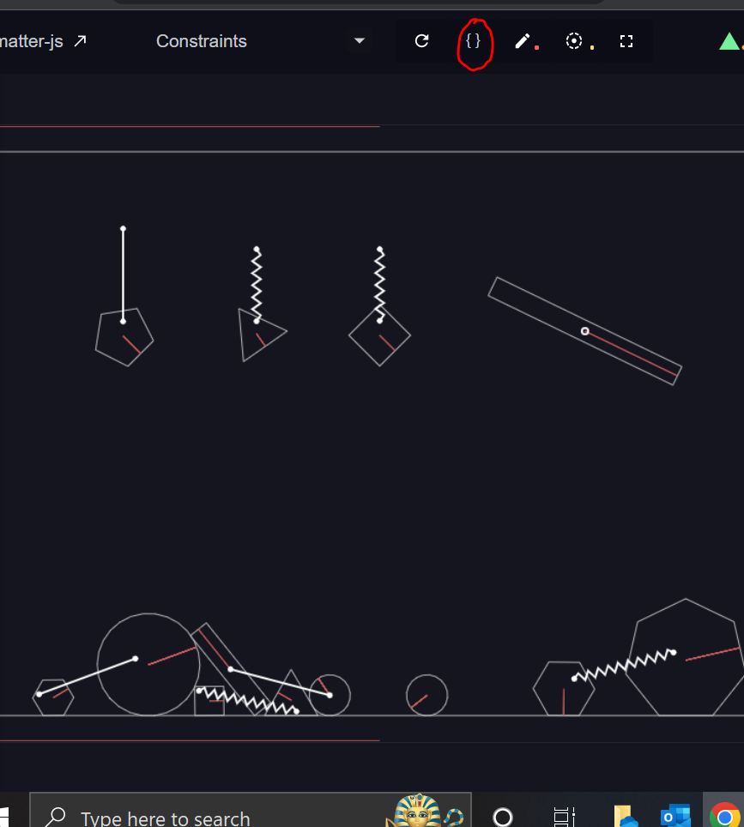

Remember the steps to create a physical object

* 1. Create the object in setup
* poly1A = Bodies.polygon(700,100,6,20);

2. Add the object to the world

World.add(engine.world, [ground, poly1A, poly1B]);

3. Draw it

  drawVertices(poly1A.vertices);

4. Add the constraint

a. Create the constraint

    constraint1 = Constraint.create({

        bodyA: poly1A,

        point1A: {x:0, y:0}, //grab from its center

        bodyB: poly1B,

        point1B: {x:-10, y:-10}, //Coordinates relative to the center

    })

b. Add the constraint to the world

World.add(engine.world, [ground, poly1A, poly1B, constraint1]);

5. Draw the constraint using the helper function

drawConstraint(constraint1);

To add the second constraint of a body poly2 constrained to a fixed point in sace

Define the constraint, the body, and add them to the word

    poly2 = Bodies.polygon(300,200,5,40);

    constraint2 = Constraint.create({

        // No bodyA. We want poly2 to be attached to a fixed point in the world

        pointA: {x:150, y:50}, //grab from its center

        bodyB: poly2,

        pointB: {x:-10, y:-20}, //Coordinates relative to the center

        stiffness:0.01 // Makes the join elastic

    })

    World.add(engine.world, [poly2, constraint2]);

Then draw the constraint and the vertices

    // Draw the objects

    strokeWeight(1);

    drawVertices(poly2.vertices);

 // Drawing the constraint

    stroke(128);

    drawConstraint(constraint2);

## 7_ Adding mouse interaction

We add these lines of codes

    // Mouse

    var mouse = Mouse.create(canvas.elt) // canvas is a p5.js construct. canvas.elt returns the actual HTML element. We get the mouse position on the canvas

    var mouseParams = {

      mouse: mouse

    }; // We put the mouse position into a mouseParams object.

    var mouseConstraint = MouseConstraint.create(engine, mouseParams); // We create a mouse constraint object. Attention mouseContraint is an instance of class MouseConstraint

    mouseConstraint.mouse.pixelratio = pixelDensity(); // Not necessary for my computer. This is for computers with low pixel density

    World.add(engine.world, mouseConstraint);  // We add the mouse constraint to the world

Here is the overall code

// Matter.js module aliases

var Engine = Matter.Engine;

var Render = Matter.Render;

var World = Matter.World;

var Bodies = Matter.Bodies;

var Constraint = Matter.Constraint;

var MouseConstraint = Matter.MouseConstraint;

var Mouse = Matter.Mouse;

// Global variables

var engine;

var ground; // a ground for the ball to bounce on

var canvas;

// System 1 - Two bodies constrained together

var poly1A;

var poly1B;

var constraint1;

// System 2 - One body constrained to a fixed point

var poly2;

var constraint2;

// System 3

var poly3;

var constraint3;

function setup() {

    canvas = createCanvas(900,600);

    // create en engine

    engine = Engine.create();

    // ground

    ground = Bodies.rectangle(width/2,height-20,800,10, {isStatic: true, angle: 0});

    World.add(engine.world, [ground]);

    // Mouse

    var mouse = Mouse.create(canvas.elt) // canvas is a p5.js construct. canvas.elt returns the actual HTML element. We get the mouse position on the canvas

    var mouseParams = {

      mouse: mouse

    }; // We put the mouse position into a mouseParams object.

    var mouseConstraint = MouseConstraint.create(engine, mouseParams); // We create a mouse constraint object. Attention mouseContraint is an instance of class MouseConstraint

    mouseConstraint.mouse.pixelratio = pixelDensity(); // Not necessary for my computer. This is for computers with low pixel density

    World.add(engine.world, mouseConstraint);  // We add the mouse constraint to the world

    // System 1: Two bodies constrained together

    poly1A = Bodies.polygon(700,100,6,20);

    poly1B = Bodies.polygon(700,250,1,50);

    constraint1 = Constraint.create({

        bodyA: poly1A,

        point1A: {x:0, y:0}, //grab from its center

        bodyB: poly1B,

        pointB: {x:-10, y:-10}, //Coordinates relative to the center

        stiffness:0.01 // Makes the join elastic

    })

    World.add(engine.world, [poly1A, poly1B, constraint1]);

    // System 2: A body constrained by a fixed point

    poly2 = Bodies.polygon(300,200,5,40);

    constraint2 = Constraint.create({

        // No bodyA. We want poly2 to be attached to a fixed point in the world

        pointA: {x:150, y:50}, //grab from its center

        bodyB: poly2,

        pointB: {x:-10, y:-20}, //Coordinates relative to the center

        stiffness:0.01 // Makes the join elastic

    })

    World.add(engine.world, [poly2, constraint2]);

    // System 3: A body constrained by a fixed point more elastically

    poly3 = Bodies.polygon(400,100,4,30);

    constraint3 = Constraint.create({

        // No bodyA. We want poly2 to be attached to a fixed point in the world

        pointA: {x:400, y:120}, //grab from its center

        bodyB: poly3,

        pointB: {x:-10, y:-20}, //Coordinates relative to the center

        stiffness:0.001, // Makes the join elastic

        damping: 0.05 // The return movement is softened a bit

    })

    World.add(engine.world, [poly3, constraint3]);

}

function draw() {

    // Update the engine at each loop of the draw() function

    background(0);

    Engine.update(engine);

    // Drawing the constraint

    stroke(128);

    strokeWeight(3);

    drawConstraint(constraint1);

    drawConstraint(constraint2);

    drawConstraint(constraint3);

    // Draw the grounds

    strokeWeight(1);

    drawVertices(ground.vertices);

    drawVertices(poly1A.vertices);

    drawVertices(poly1B.vertices);

    drawVertices(poly2.vertices);

    drawVertices(poly3.vertices);

}

// ***********HELPER FUNCTIONS *************//

function drawConstraint(constraint) {

    var offsetA = constraint.pointA;

    var posA = {x:0, y:0};

    if (constraint.bodyA) {

      posA = constraint.bodyA.position;

    }

    var offsetB = constraint.pointB;

    var posB = {x:0, y:0};

    if (constraint.bodyB) {

      posB = constraint.bodyB.position;

    }

    line(

      posA.x + offsetA.x,

      posA.y + offsetA.y,

      posB.x + offsetB.x,

      posB.y + offsetB.y

    );

  }

function drawVertices(vertices) {

    beginShape();

    for (var i=0; i<vertices.length; i++) {

        vertex(vertices[i].x, vertices[i].y);

    }

    endShape(CLOSE);

}

## 8_ Hack it catapult

* Add code in setupCatapult() that initialises the global catapult variable as a rectangle (the white rectangle).
* Add also a constraint right in the middle of the white rectangle that has a stiffness of 1 and length of 0.
* Add the catapult and the constraint to the world.
* Add code to drawCatapult() to draw the catapult like in drawGround().
* Add a bit more code that sets up the red rectangle you see in the image, that acts as a support. Add the catapultSpace to the world.
* Add code to drawCatapult() to draw the catapultSpacer like in drawGround().
* Add code to setupBalls() to setup two balls like in the example above. Set the density of ball1 to 0.01 so that the ball has a lot of weight.
* Add code to drawBalls() to draw the two balls you created.

Here the instruction do not detail enough how the catapult works. So I type in google matter.js demo and find the catapult code

<https://github.com/liabru/matter-js/blob/master/examples/catapult.js>

This was an excellent exercice. The main learnings are

* Look up the matter.js documentation and especially the catapult demo
* The constraint is defined like this : the catapult is constrained by its center.
* constraint = Constraint.create({
* bodyA : catapult,
* pointB: Vector.clone(catapult.position), // pointA = pointB so length is 0
* stiffness: 1,
* length: 0
* })

Note that documentation says that pointA and pointB must be defined as vectors

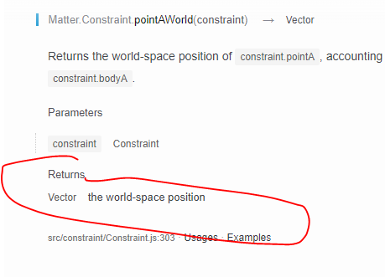

* The catapult spacer, ie the red rectangle, must be defined as a matter.js object to have the physical property of supporting the catapult. If you define it as a rect() in p5.js it will be only a drawing on the canvas with no physical property

  catapultSpacer = Bodies.rectangle(

    catapult.position.x-250,

    catapult.position.y + 50,20,75, {isStatic: true});

}

* The balls: The higher the density the more weight.

So here is the code that works

// Example is based on examples from:

// http://brm.io/matter-js/

// https://github.com/shiffman/p5-matter

// https://github.com/b-g/p5-matter-examples

/*

• Add code in setupCatapult() that initialises the global catapult variable as a rectangle (the white rectangle).

• Add also a constraint right in the middle of the white rectangle that has a stiffness of 1 and length of 0.

• Add the catapult and the constraint to the world.

• Add code to drawCatapult() to draw the catapult like in drawGround().

• Add a bit more code that sets up the red rectangle you see in the image, that acts as a support. Add the catapultSpace to the world.

• Add code to drawCatapult() to draw the catapultSpacer like in drawGround().

• Add code to setupBalls() to setup two balls like in the example above. Set the density of ball1 to 0.01 so that the ball has a lot of weight.

• Add code to drawBalls() to draw the two balls you created.

*/

// module aliases

var Engine = Matter.Engine;

var Render = Matter.Render;

var World = Matter.World;

var Bodies = Matter.Bodies;

var Constraint = Matter.Constraint;

var Vector = Matter.Vector;

// Global variables

var engine;

var ground;

var ball1;

var ball2;

var catapult;

var catapultSpacer; // This is the red rectangle that acts as support

var constraint;

function setup() {

  createCanvas(800, 600);

  engine = Engine.create(); // create an engine

  setupCatapult();

  setupBalls();

  setupGround();

// Add also a constraint right in the middle of the white rectangle that

//  has a stiffness of 1 and length of 0.

  // Constraint 1: At the middle of the catapult

  constraint = Constraint.create({

    bodyA : catapult,

    pointB: Vector.clone(catapult.position), // pointA = pointB so length is 0

    stiffness: 1,

    length: 0

  })

  // Add the catapult and the constraint to the world.

  World.add(engine.world, [catapult, catapultSpacer, constraint, ball1, ball2]);

}

/////////////////////////////////////////////////////////////

function draw() {

  background(0);

  Engine.update(engine);

  drawBalls();

  drawCatapult();

  drawGround();

  // Add a bit more code that sets up the red rectangle you see in the image, that acts as a support. Add the catapultSpace to the world.

}

/////////////////////////////////////////////////////////////

// •  Add code in setupCatapult() that initialises the global catapult

//  variable as a rectangle (the white rectangle).

function setupCatapult(){

  // Attention rectangle is defined from the center in matter.js

  // Catapult must not be static in order for it to move

  catapult = Bodies.rectangle(0.5*width, 0.8*height, 0.8*width,20, );

  // Red rectangle below the catapult that support it. Attention if you define it as a rect in draw() directly it will have nophysical effect !

  catapultSpacer = Bodies.rectangle(

    catapult.position.x-250,

    catapult.position.y + 50,20,75, {isStatic: true});

}

/////////////////////////////////////////////////////////////

// •  Add code to drawCatapult() to draw the catapult like in drawGround().

// •  Add code to drawCatapult() to draw the catapultSpacer like in drawGround().

function drawCatapult(){

  // your code here

  noStroke();

  fill(255);

  drawVertices(catapult.vertices);

  fill(255,0,0);

  drawVertices(catapultSpacer.vertices);

}

//  Add code to setupBalls() to setup two balls like in the example above.

// Set the density of ball1 to 0.01 so that the ball has a lot of weight.

/////////////////////////////////////////////////////////////

function setupBalls(){

  // your code here

  ball1 = Bodies.circle(catapult.position.x-200,0,20);

  ball2 = Bodies.circle(catapult.position.x+200,0,60,{density: 0.01});

}

/////////////////////////////////////////////////////////////

function drawBalls(){

  // your code here

  fill(0,0,255);

  drawVertices(ball1.vertices);

  drawVertices(ball2.vertices);

}

/////////////////////////////////////////////////////////////

function setupGround(){

  ground = Bodies.rectangle(400, height-10, 810, 25, {isStatic: true});

  World.add(engine.world, [ground]);

}

/////////////////////////////////////////////////////////////

function drawGround(){

  noStroke();

  fill(128);

  drawVertices(ground.vertices);

}

////////////////////////////////////////////////////////////////

// ******* HELPER FUNCTIONS *********

// DO NOT WRITE BELOW HERE

/////////////////////////////////////////////////////////////

function drawVertices(vertices) {

  beginShape();

  for (var i = 0; i < vertices.length; i++) {

    vertex(vertices[i].x, vertices[i].y);

  }

  endShape(CLOSE);

}

# Week 5: Animating a static object: Propeller

## Video: Animating a static object

The object here is to create a propeller, ie a motor object that has a movement of its own.

We

First we create the propeller simply by creating a rectangle body, and updating its angle position at every frame

    propeller = Bodies.rectangle (width/2, height/2, 300, 15, {isStatic: true, angle: angle})

drawVertices(propeller.vertices);

angle += 0.1;

Body.setAngle(propeller, angle);

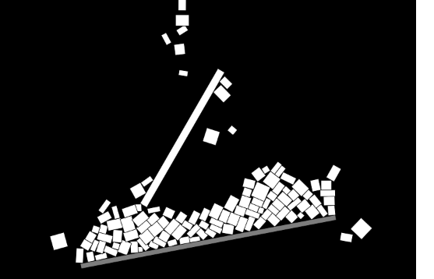

The second step is explained in the comments

// At this point, at each frame the angle of the propeller is incremented, but within that frame, it is as if the boxes

    // are hitting a frame that is fixed. We need to tell matter.js that the propeller is actually hitting

    // the boxes with some velocity.We do this by giving the propeller an angularSpeed > 0. note that

    // angular speed is a propertuy of the propeller (do a console.log propeller.angularSpeed)

    Body.setAngularVelocity(propeller, angleSpeed);

    angle += angleSpeed;

    // Now, instead of simply landing on the propeller, the boxes are hit by the propeller and are projected

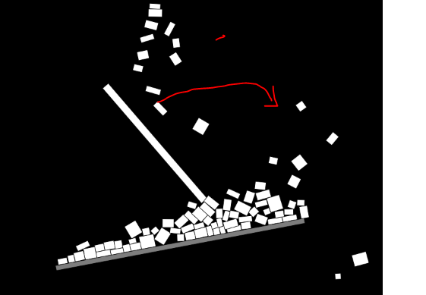

This distinction is Important to understand: the AngularVelocity property of the object communicates to other objects that enter in collision with them that this object is hitting them with some speed and is not inert.

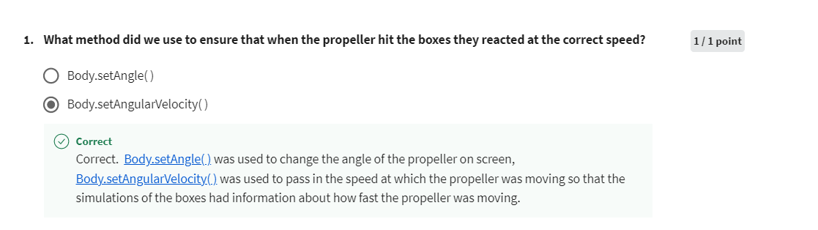

So here is the whole code for the propeller

// module aliases -- nicknames that make the command shorter

var Engine = Matter.Engine;

var Render = Matter.Render;

var World = Matter.World;

var Bodies = Matter.Bodies;

var Body = Matter.Body;

// Global variables

var engine;

var box1; // A body that we will create

var ground; // a ground for the ball to bounce on

var boxes = [];

var propeller;

var angle = 0; // Angle for the propeller

var angleSpeed = 0.1; // Angular speed of propeller. Amound by which the angle increases between two frames

function setup() {

    createCanvas(900,600);

    // create en engine

    engine = Engine.create();

    // we create our first body and the ground

        // box is falling with gravity. Restitution is the energy with which it bounces

    box1 = Bodies.rectangle(50,0,50,50, {restitution:0.8, friction: 0.5});

    // ground and propeller are not falling because of gravity

    ground = Bodies.rectangle(500,500,500,10, {isStatic: true, angle: Math.PI * -0.06});

    propeller = Bodies.rectangle (width/2, height/2, 300, 15, {isStatic: true, angle: angle})

    // We add all the bodies to the word

    World.add(engine.world, [box1, ground, propeller]);

}

function draw() {

    // Update the engine at each loop of the draw() function

    background(0);

    Engine.update(engine);

    // Draw the object . Check in console engine.world.bodies

    fill(255);

    drawVertices(box1.vertices);

    drawVertices(propeller.vertices);

    Body.setAngle(propeller, angle);

    // At this point, at each frame the angle of the propeller is incremented, but within that frame, it is as if the boxes

    // are hitting a frame that is fixed. We need to tell matter.js that the propeller is actually hitting

    // the boxes with some velocity.We do this by giving the propeller an angularSpeed > 0. note that

    // angular speed is a propertuy of the propeller (do a console.log propeller.angularSpeed)

    Body.setAngularVelocity(propeller, angleSpeed);

    angle += angleSpeed;

    // Now, instead of simply landing on the propeller, the boxes are hit by the propeller and are projected

    if (random(1)<0.2) generateObject(width/2, 0); // The if statement slows down the generation process to every 5th frame.

    for (var i=0; i<boxes.length; i++) {

        drawVertices(boxes[i].vertices);

        if (isOffScreen(boxes[i])) {

            // Remove box from physics engine

            World.remove(engine.world, boxes[i]);

            //  Remove box from drawing. Chck in console boxes.length

            boxes.splice(i,1);

            // the next box will not be checked because it is moved one position down and the iterator moves one position up

            //So we need to reexecute the code at i beforemoving to i+1

            // We achieve this this way

            i--;

        }

        //

    }

    // Draw the grounds

    fill(125);

    drawVertices(ground.vertices);

}

// Function that generates objects at position x and y

function generateObject(x,y) {

    var b = Bodies.rectangle(x,y, random(10,30), random(10,30), {restitution: 0.8, friction: 0.5})

    boxes.push(b);

    // Tells the physics engine to keep calculating the object position

    World.add(engine.world,[b]);

}

// Function that eliminates objects When off screen

// Which will prevent then physics engine from slowing down

function isOffScreen(body) {

    // returns true if y position > height

    var pos = body.position;

    return (pos.y>height || pos.x <0 || pos.x >width);

}

function drawVertices(vertices) {

    beginShape();

    for (var i=0; i<vertices.length; i++) {

        vertex(vertices[i].x, vertices[i].y);

    }

    endShape(CLOSE);

}

## Hack it: Dominoes - Composites

Here you should read about composites

<https://brm.io/matter-js/docs/classes/Composites.html>

And you should see the demo

<https://brm.io/matter-js/demo/#compoundStack>

I use this

<https://code.tutsplus.com/tutorials/getting-started-with-matterjs-composite-and-composites-module--cms-28836>

Matter.js has two main modules that allow to to manipulate bodies

* The Body module, that we saw, enables to manipulate simple bodies like circles and rectangles
* The composite and composites module allow to manipulate more complex modules such as cars, chains…

To create a stack use

stack(xx, yy, columns, rows, columnGap, rowGap, callback)

The names of all the parameters are self-explanatory. The xx and yy parameters used in this function are used to specify the starting point of the composite. The columns and rows parameters determine the number of columns and rows in the composite. The gap between different rows and columns can be controlled using the columnGap and rowGap parameters.

The callback function is used to create bodies that can be arranged in either a grid arrangement or a pyramid arrangement based on the function used. This means that you can use it to create a stack or pyramid of rectangular boxes or trapezoids. You should keep in mind that using a circle will make the arrangements unstable. Here is the code to create a stack of rectangles:

**var** stack = Composites.stack(550, 100, 5, 3, 0, 0, **function**(x, y) {

**return** Bodies.rectangle(x, y, 40, 20, {

    render: {

      fillStyle: 'orange',

      strokeStyle: 'black'

    }

  });

});

I copy this code into the hack it code in setup function, removing the initial var

function setupDominoes(){

   // your code here

   stack = Composites.stack(550, 100, 5, 3, 0, 0, function(x, y) {

    return Bodies.rectangle(x, y, 40, 20, {

      render: {

        fillStyle: 'orange',

        strokeStyle: 'black'

      }

    });

  });

}

This code means that

* the stack starts at position (550,100). Attention its position will change due to gravity
* The stack is a grid made of 5 columns and 3 lines. Each element of the grid will contain the body defined inside the callback function
* 0,0 is the gap between the columns and rows. You can increase it to visualize the gap
* The callback defines the bodies drawn inside each element of the grid

Then playing with the console helps figure out what the stack is made of

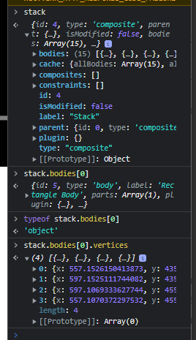

And I draw using a for loop

function drawDominoes(){

  // your code here

  // drawVertices(stack.vertices);

  for (var i=0; i<stack.bodies.length; i++) {

    drawVertices(stack.bodies[i].vertices);

  }

}

And so we get this

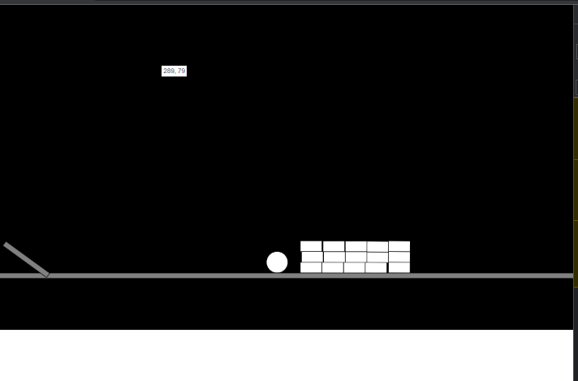

Then it is just a matter of readapting my code so that it gives dominoes

function setupDominoes(){

   // your code here

   stack = Composites.stack(100, 250, 35, 1, 10, 0, function(x, y) {

    return Bodies.rectangle(x, y, 10, ground.position.y-250, {

      render: {

        fillStyle: 'orange',

        strokeStyle: 'black'

      }

    });

  });

}

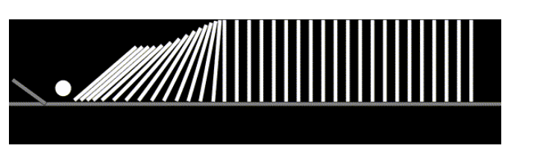

Here is the whole code

/*

This is a challenge for students to do some investigative work of their own into Matter.js. You should read the Matter.js documentation about composites. You can look at an available demo of how to implement a composite along with the code for that demo.

Setup the dominoes above. Start by using the template code attached.

dominoes-Template

Add code in setupDominoes() function using a composite.

Add code in the drawDominoes() function to draw the pieces using the drawVertices() helper function. Remember to loop through each object in the stack.

*/

// Example is based on examples from:

// http://brm.io/matter-js/

// https://github.com/shiffman/p5-matter

// https://github.com/b-g/p5-matter-examples

// module aliases

var Engine = Matter.Engine;

var Render = Matter.Render;

var World = Matter.World;

var Bodies = Matter.Bodies;

var Composites = Matter.Composites;

var engine;

var ball;

var ground;

var stack;

function setup() {

  createCanvas(1200, 600);

  // create an engine

  engine = Engine.create();

  ball = Bodies.circle(30, 0, 20, {restitution:1, friction: 0, density: 0.003});

  var options = {isStatic: true, angle: Math.PI * 0};

  ground = Bodies.rectangle(width/2, 500, width, 10, options);

  smallGround = Bodies.rectangle(50, 470, 100, 10, {isStatic: true, angle: Math.PI * 0.2});

  setupDominoes();

  // add all of the bodies to the world

  World.add(engine.world, [ground, ball, smallGround, stack]);

}

/////////////////////////////////////////////////////////

function draw() {

  background(0);

  Engine.update(engine);

  fill(255);

  drawVertices(ball.vertices);

  drawDominoes();

  fill(128);

  drawVertices(ground.vertices);

  drawVertices(smallGround.vertices);

}

/////////////////////////////////////////////////////////

// Add code in setupDominoes() function using a composite.

// atter.Composites.stack(xx, yy, columns, rows, columnGap, rowGap, callback)

function setupDominoes(){

   // your code here

   stack = Composites.stack(100, 250, 35, 1, 10, 0, function(x, y) {

    return Bodies.rectangle(x, y, 10, ground.position.y-250, {

      render: {

        fillStyle: 'orange',

        strokeStyle: 'black'

      }

    });

  });

}

/////////////////////////////////////////////////////////

function drawDominoes(){

  // your code here

  // drawVertices(stack.vertices);

  for (var i=0; i<stack.bodies.length; i++) {

    drawVertices(stack.bodies[i].vertices);

  }

}

/////////////////////////////////////////////////////////

// ********* HELPER FUNCTIONS **********

/////////////////////////////////////////////////////////

function drawVertices(vertices) {

  beginShape();

  for (var i = 0; i < vertices.length; i++) {

    vertex(vertices[i].x, vertices[i].y);

  }

  endShape(CLOSE);

}

"C:\Users\yassi\OneDrive\1_Work\2_Innovation\2_WebMobile\1_Web\1_UolDegree\2_Course\2_Level5\4_GraphicsProgramming\Week5\code\HackItDominoes"

## Graded assignment: Angry birds

* To create a propeller that rotates, you must set isStatic to true to prevent the propeller from being sucked by gravity. This does not prevent it from moving with an angle.
* function setupPropeller(){
* // your code here
* propeller = Bodies.rectangle(150, 480, 200, 15, {
* isStatic: true,angle: angle
* });
* World.add(engine.world, [propeller]);
* }
* Note that in step 4 I use a composite instead of what they do

My extension: game

I use isOffscreen for the stack so that boxes are removed from stack when offscreen

function drawTower(){

  //your code here

  for (var i=0; i<stack.bodies.length; i++) {

    fill(0, colors[i],0);

    drawVertices(stack.bodies[i].vertices);

    if (isOffScreen(stack.bodies[i])) {

      removeFromWorld(stack.bodies[i]);

      stack.bodies.splice(i, 1);

    }

  }

This allows to use the condition on stacks for winning or game over

if (frameCount % 60 == 0 && timer > 0) { // if the frameCount is divisible by 60, then a second has passed. it will stop at 0

    timer --;

  }

  if (timer == 0 && stack.bodies.length > 0 ) {

    textSize(32);

    fill(255,0,0);

    text("GAME OVER", width/2-100, height/2);

    noLoop();

  }

  if (stack.bodies.length ==  0) {

    textSize(32);

    fill(255,255,0);

    text("WELL DONE !", width/2, height/2);

    noLoop();

  }

# Week 6: generative techniques: Randomness and noise

47min /2 = 23.5minutes

Morning finish introduction and randomness

## 1_ Introduction to Generative art and design

### Definition of generative art

Generative art = art that has been created with the use of an autonomous system

A Metaphor a generative design programmer is like a gardener. Because you define the logic of the drawing but you do not control the exact parts of the drawing. Like a gardener who seeds but does not control nature

Painting of Isaac newton and its scrultral representation at the entry of the museum of London

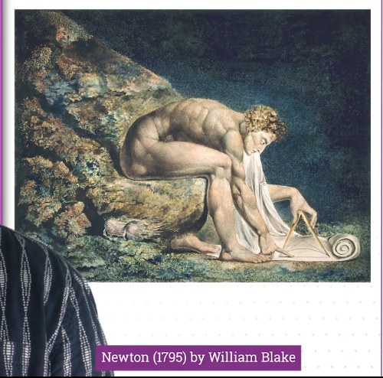

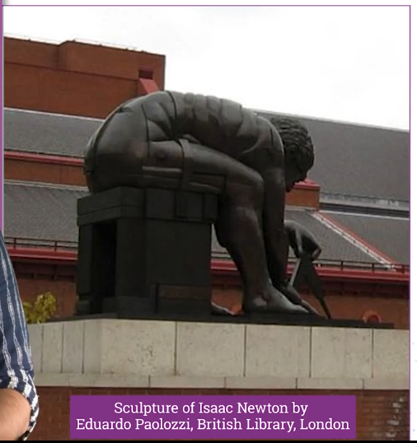

Generative designers design processes based on processes they observe in nature

The challenge is to manipulatethe mechanical to produce the organic like this

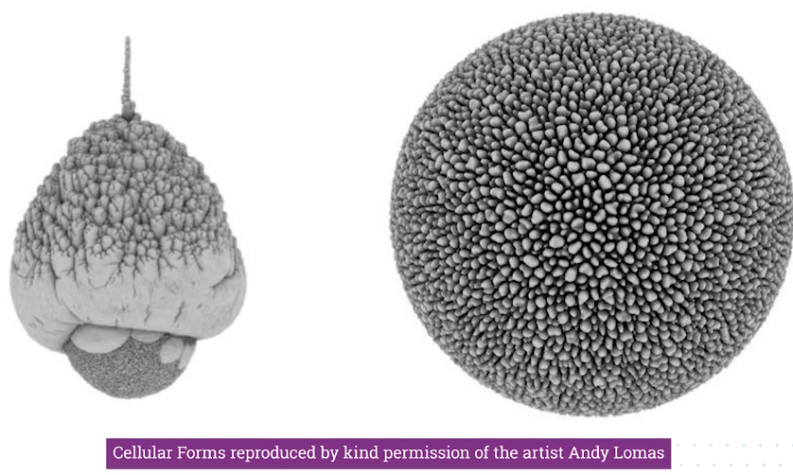

One reason of generative design is to allows artist to explore the full gamete of options without their taste affecting the results.

### Application 1: Procedural generation in game development

Gneerative design encompasses procedural generation in game development where content is created quasi randomly by a computer

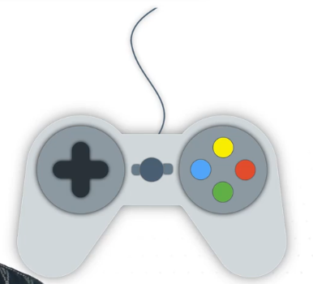

Games that reproduce civilizations like Minecraft generate entire maps and worlds this way.

Procedural generation in games produces

* Random Environments
* Random enemy encounters

Therefore it can give the player unlimited content so that he can play forever with infinite variations. So you can enjoy the same game for years in ways you could not with a fixed experience. The player is offered constantly new challenges preventing him from simply learning the game through memory.

### Application 2: Fabrication

Another field influenced by generative design is fabrication. It is the production of physical objects based on the designs produces using generative design using for example 3D printers of laser cutters or CNC mills

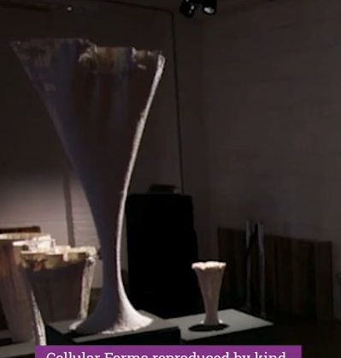

For example this vase is produces by andy lomas using algorithm techniques that replicate how things in nature actually grow

## 2_ Nature and use of randomness

### Seeding

Randomness allows to hand a range of values of a process to an algorithm

Throwing dice is not random because it can be predicted using the speed at which we throw the dice,air temperature …

A better system is to generate random numbers based on the radioative decay of an atom because we cannot truly predict what happens inside an atom

The computer does not really generate truly random numbers. It generates pseudo random numbers that look like random numbers but in truth they are not. The algorithm it uses to generate random numbers depends entirely on the initial value the algorithm is given, known as **seed value**  or **key.** The entire seemingly random series can be reproduced if the seed value is known

Generally the starting point (seed) is given y the time in the computer, given that the time is unique

Q. Generate in the screen random circles with random position, red shade, transparency and size like this

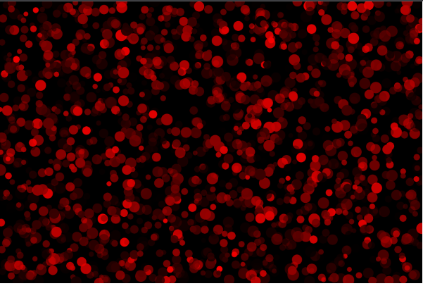

Answer

function setup() {

    createCanvas(900, 600);

    background(0);

}

function draw() {

    var randX = random(0, width); // Random number between 0 and width. can be written as random(width) and the 0 is optionnal

    var randY = random(0, height);

    noStroke();

    fill(random(255), 0, 0, random(255));

    var size= random(10,25);

    ellipse(randX, randY, size, size);

}

Q. now fix the seed number so that the random() function always generates the same numbers

In setup we use the ransdomSeed and pass it any number we want

This allows you to generate the same random values all the time

function setup() {

    createCanvas(900, 600);

    background(0);

    randomSeed(0); // The seed starting point of the random function is the same. Therefore the random() function generates teh same series of numbers everytime it is called

    // ransomSeed(50) would produce a different pattern

}

function draw() {

    var randX = random(0, width); // Random number between 0 and width. can be written as random(width) and the 0 is optionnal

    var randY = random(0, height);

    noStroke();

    fill(random(255), 0, 0, random(255));

    var size= random(10,25);

    ellipse(randX, randY, size, size);

}

If you use randomSeed(50) you could say that this is generative design 50

Randomness can be used to

* Position object and define their size or color
* To add a random offset to a position to some values
* To decide movement in a system like random walk
* It is used to determine the probability of an event happening for example
* var r = random(0,1);
* if (r<0.3) {} // X happens with 30% probability
* else if (r<0.9) {} // Y happens with 60% probability
* else {} // Z happens with 10% probability

However random noise is not good at producing random patterns

We will see that Perlin noise is a better tool for that

### Two ways to generate random numbers: pseudorandom (algorithms) and physical processes

Q. Quizz: Can computers generate truly random numbers ?

Yes actually.

There are two ways of generating random numbers

* Using an algorithm
* Using physical processes

For example hardware random number generators use physical processes

<https://en.wikipedia.org/wiki/Hardware_random_number_generator>

In [computing](https://en.wikipedia.org/wiki/Computing), a **hardware random number generator** (**HRNG**) or **true random number generator** (**TRNG**) is a device that [generates random numbers](https://en.wikipedia.org/wiki/Random_number_generation) from a [physical process](https://en.wikipedia.org/wiki/Physical_process), rather than by means of an [algorithm](https://en.wikipedia.org/wiki/Algorithm). Such devices are often based on microscopic phenomena that generate low-level, [statistically random](https://en.wikipedia.org/wiki/Statistically_random) "[noise](https://en.wikipedia.org/wiki/Noise_(signal_processing))" signals, such as [thermal noise](https://en.wikipedia.org/wiki/Thermal_noise), the [photoelectric effect](https://en.wikipedia.org/wiki/Photoelectric_effect), involving a [beam splitter](https://en.wikipedia.org/wiki/Beam_splitter), and other [quantum](https://en.wikipedia.org/wiki/Quantum) phenomena. These [stochastic](https://en.wikipedia.org/wiki/Stochastic) processes are, in theory, completely unpredictable for as long as an equation governing such phenomena is unknown or uncomputable. This is in contrast to the paradigm of [pseudo-random number generation](https://en.wikipedia.org/wiki/Pseudorandom_number_generator) commonly implemented in [computer programs](https://en.wikipedia.org/wiki/Computer_program).

Another example in cryptography that uses entropy to generate random number

Ideally, the generation of random numbers in CSPRNGs uses entropy obtained from a high-quality source

<https://en.wikipedia.org/wiki/Cryptographically_secure_pseudorandom_number_generator>

Even through your program uses pseudorandom numbers there are instances where you need truly random numbers like cryptography

### Hack it: Ticke walker

Write a sketch in which a circle is drawn.

When the mouse is inside the circle add a random value to the location of the circle in order for your sketch to behave the way shown in the image above.

Challenge yourself a bit more by making the "tickle walker" object oriented, by making "Tickler" class.

Answer

Here is my code. I did it without the class then I put everything inside the class

var circle;

var mouse;

var walker1;

function setup() {

    createCanvas(900, 600);

    background(0);

    randomSeed(100);

    walker1 = new Walker();

}

function draw() {

    background(0); // clear the screen at each loop

    walker1.draw();

}

class Walker {

    constructor() {

        this.x = width/2;

        this.y = height/2;

        this.radius = 50;

    }

    draw() {

        mouse = createVector(mouseX, mouseY);

        if(dist(mouse.x, mouse.y, this.x, this.y) < this.radius) {

            this.x += random(-10, 10);

            this.y += random(-10, 10);

    }

        ellipse(this.x,

                this.y,

                this.radius,

                this.radius);

    }

}

### Hack it: Random Font

First reflex is to inspect the points objects in the console to understand how it can be manipulated

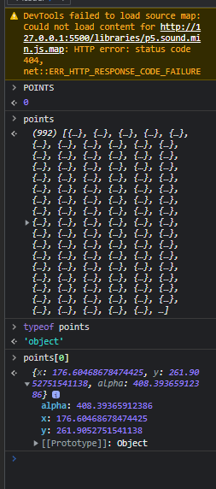

Easy one here is my solution code

/*

In this programming exercise, you’re asked to use the points that make up the word

 to generate an interesting new font like in the image above.

Warning: Remember, use Bracket’s live view to view your sketch.

Loading fonts will not work when the html is viewed independently in chrome.

randomFont-Template

Steps to complete

Step 1: Start by downloading the template project attached.

Step 2:  In the draw() function loop over the points array. This array has the locations of the points that make up the word “code”, p5.js textToPoints() returns an array of p5.js points. Display them as circles at their x and y coordinates using ellipse().

Step 3: In the loop over the points array, use the random() function to add a random amount to the x and y coordinates of each point in order to make it appear in a new location. HINT: the random() function will return a different range of values depending on how many arguments are passed into it, look at the p5.js random() reference to remind yourself.

Step 4: Use mouseX to vary the range the random() function takes to generate the value that you add to the location of each point. HINT: you can use the map() function to map mouseX to a new range.

Notice that the sketch stops generating new patterns when the mouse

stops moving. That’s because at the bottom of the draw() function

the noLoop() command is called which stops the sketch from looping

further. At the same time, inside the mouseMoved() function we call

 the loop() function which reactivates the sketch when the mouse is

 moved.

*/

var font;

function preload() {

  font = loadFont('assets/Calistoga-Regular.ttf');

}

var points;

var blur;

function setup() {

  createCanvas(900, 400);

  fill(255, 104, 204, 150);

  noStroke();

  points = font.textToPoints('c o d e', 50, 300, 300, {

    sampleFactor: .3,

    simplifyThreshold: 0

  });

}

function draw() {

    background(0);

    blur = map(mouseX, 0,width, 10,50);

    console.log(blur);

    // *** your code here ****

    // Step 2:  In the draw() function loop over the points array.

    // This array has the locations of the points that make up the word

    //  “code”, p5.js textToPoints() returns an array of p5.js points.

    //  Display them as circles at their x and y coordinates using ellipse().

    // Step 3: In the loop over the points array, use the random() function

    // to add a random amount to the x and y coordinates of each point in

    // order to make it appear in a new location. HINT: the random()

    // function will return a different range of values depending on how

    // many arguments are passed into it, look at the p5.js random()

    //  reference to remind yourself.

    for (var i=0; i<points.length; i++) {

      ellipse(points[i].x+random(blur), points[i].y+random(blur), 20, 20);

    }

    noLoop();

}

function mouseMoved(){

    loop();

}

## 3_Introduction to Perlin noise

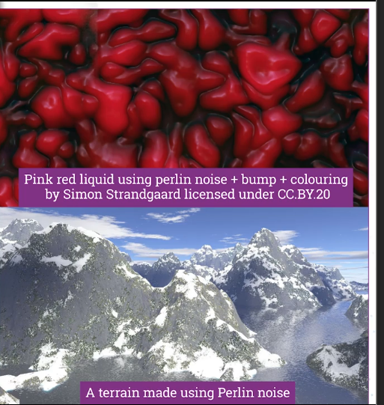

The reason we use perlin noise is that it has an organic and natural appearance

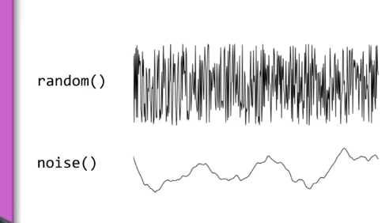

The difference is that Perlin noise is smoother. Because each value generated takes into account the value before. This is not the case with random() function. Basically the sequence generated in Perlin noise is more persistent. Think about nature. Temperature does not change a lot in small time temperature

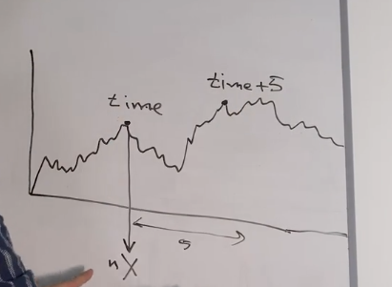Because of this persistency we can think of perlin noise a s functuin of time. The further away the time argument,



Code producs a square whose properties change using perlin noise,

P5 noise() function produces a perlin noise sequence. It returns a value between 0 and 1. So you need to use map() to make it affect the variable you want

So here is the code

var time = 1000;

var nX;

var nY;

function setup() {

    createCanvas(900, 600);

    background(0);

    rectMode(CENTER); // When I define a rectangle the location is the center not the topleft

}

function draw() {

    background(0);

    nX = noise(time);

    nY = noise(time+5);  // attention if noise(time) then nX=nY ie you generate the same random value

    // see p5 documentation. Returns the Perlin noise value at specified coordinates

    // noise returns a random value between 0 and 1

    nY = noise(time+5);  // attention if noise(time) then nX=nY ie you generate the same random value

    var locX = map(nX, 0,1,0,width);

    var g = map(nX, 0,1,0,255);

    var locY = map(nY,0,1,0,height);

    var rotZ = map(nX, 0,1,-25,25);

    translate(locX, locY);

    rotate(rotZ);

    fill(0,g,0);

    rect(0,0,100,100);

    time += 0.01;

    // The shape moves around teh center of the screen because that is where the majority of teh distribution lies

    // if we do translate(random(width), height/2) the value can be anywhere to the left or right

    // So it is a different behavior

}

## 4_2D Noise

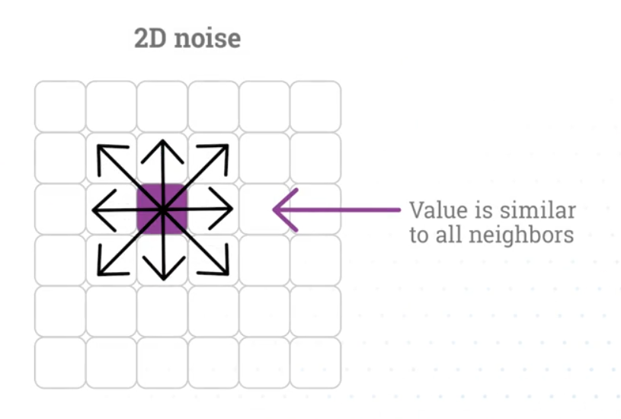

If we apply random noise we get tchahe like old TVs

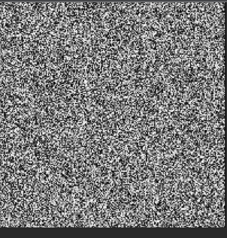

If we apply perlin we get a nuch smoother image

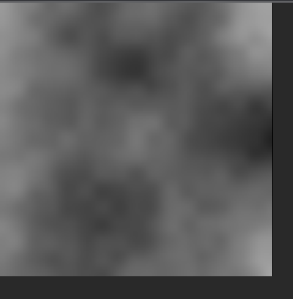

The Perlin noise works by by adding multiple noises with different frequencies ti create a noise wave. In the noise waves there are multiple calls to the rando(0 function

These waves that are added together are called octaves. In p5 noise() comes with 4 octaves

We can seed the noise function using noiseSeed(10)

Noisedetail(4) the hgher the argument the more volatile the noise function

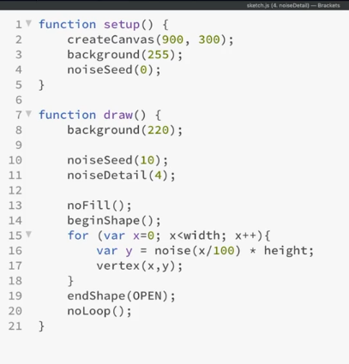

Lead to this

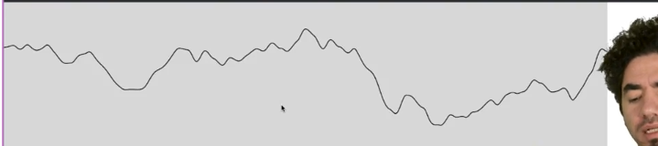

function setup() {

    createCanvas(100, 100);

    background(0);

}

function draw() {

    background(0);

    noiseDetail(7);

    noiseGrid();

}

function noiseGrid() {

    // Give each pixel a random color

    for (var x=0; x<width; x++) {

        for (var y=0; y<innerHeight; y++) {

            var n = noise(x/100,y/100); //A step of 1 is huge for the noise function so we divide by 100

            var c = map(n,0,1,0,255)

            stroke(c);

            point(x,y);

        }

    }

}

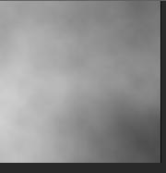

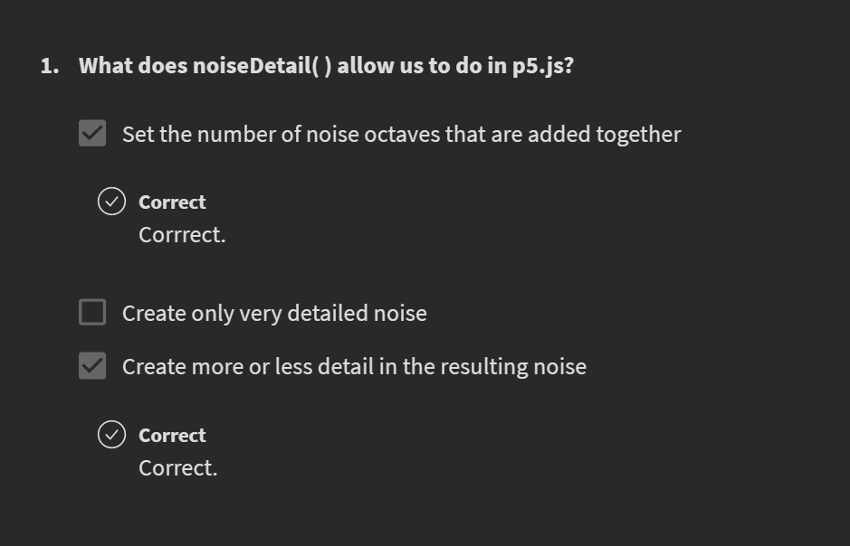

## 5_3D noise

We add one parameter to the noise function. It creates a mist that moves in time

function setup() {

    createCanvas(100, 100);

    background(0);

}

function draw() {

    background(0);

    noiseDetail(7);

    noiseGrid();

}

function noiseGrid() {

    // Give each pixel a random color

    for (var x=0; x<width; x++) {

        for (var y=0; y<innerHeight; y++) {

            var n = noise(x/100,y/100, frameCount/50); //A step of 1 is huge for the noise function so we divide by 100

            var c = map(n,0,1,0,255)

            stroke(c);

            point(x,y);

        }

    }

}

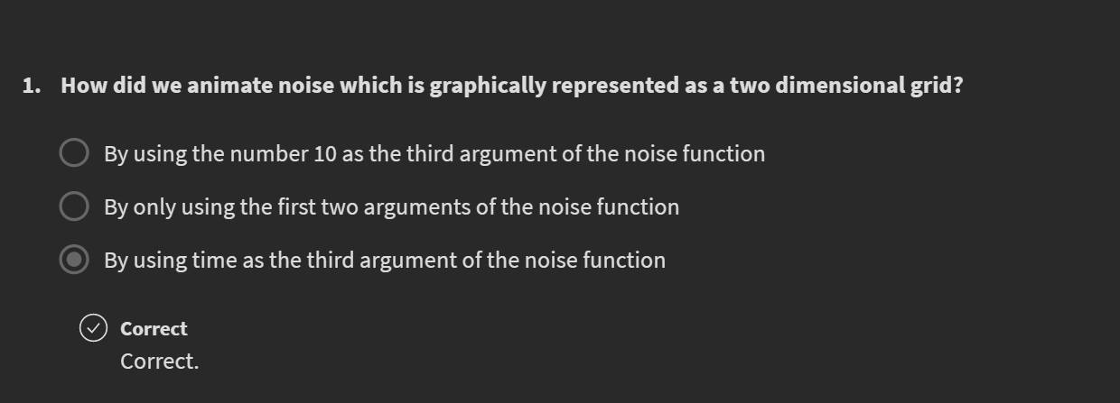

# Week 7

## Step 1

Step 1: Amend the colorGrid() function and create a

25x25 grid of rectangles. The rectangles should be of

width and height equal to stepSize, the global variable

 already provided. Set the fill to white and the stroke

 to black, to make sure the grid is correctly setup.

*/

function colorGrid(){

  // your code here

  fill(255);

  stroke(0);

  for (var i=0; i<25; i++) {

    for (var j=0; j<25; j++) {

      rect(width*i/25,height*j/25, stepSize, stepSize);

    }

  }

}

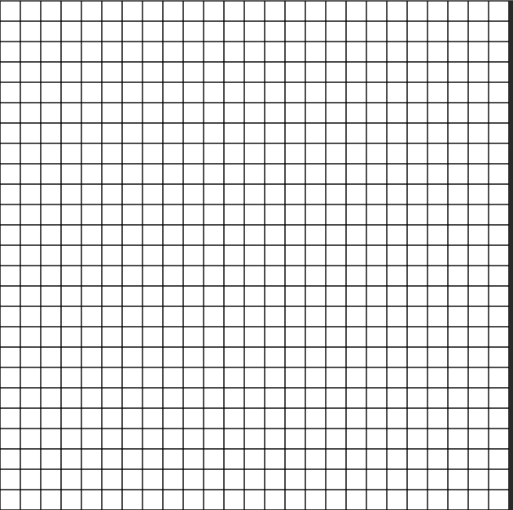

## Step 2

Lerpcolor()

<https://p5js.org/reference/#/p5/lerpColor>

Blends two colors to find a third color somewhere between them. The amt parameter is the amount to interpolate between the two values where 0.0 is equal to the first color, 0.1 is very near the first color, 0.5 is halfway in between, etc. An amount below 0 will be treated as 0. Likewise, amounts above 1 will be capped at 1. This is different from the behavior of [lerp()](https://p5js.org/reference/#/p5/lerp), but necessary because otherwise numbers outside the range will produce strange and unexpected colors.

/*

Step 2:

For each of the tiles generate a 3D noise value, using the tile’s x and y

coordinate as well as the frameCount so that the noise values change over

time. Make sure you scale the input parameters of the noise function

appropriately so that you get organic values out of it. Use that noise

value to lerp (aka interpolate) between red and green.Use the lerpColor()

function (see p5.js examples) to do so. Remove the rectangle’s stroke and

use color returned from the lerpColor() function to fill the rectangle. If

you’ve done things right you should see a grid of tiles with slowly

changing colors.

If the color of your rectangles are changing rapidly or are not smooth

like the gif above, double check how you have scaled the input parameters

for noise().

*/

function colorGrid(){

  // your code here

  for (var i=0; i<25; i++) {

    for (var j=0; j<25; j++) {

      // tile position

      var tileX = width*i/25;

      var tileY = height*j/25;

      //tile color

      var n = noise(tileX/1000, tileY/1000, frameCount/50);

      console.log(n);

      var from = color(255,0,0);

      var to = color(0,255,0);

      var inter = lerpColor(from, to, n);

      // draw tile

      fill(inter);

      noStroke();

      rect(tileX,tileY, stepSize, stepSize);

    }

  }

}

You get this and it is moving

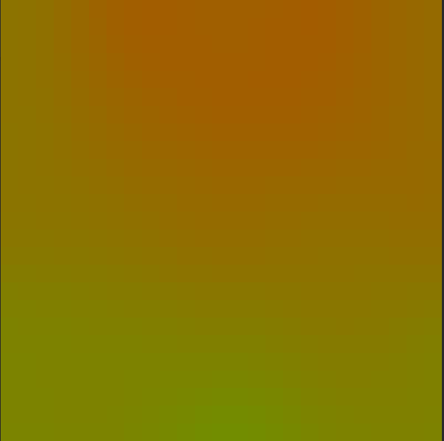

## Step 3

/*

Step 3: Make the grid color change speed be dependent on the x coordinate

of the mouse (ie small mouseX, faster color changes).

*/

function colorGrid(){

  // your code here

  for (var i=0; i<25; i++) {

    for (var j=0; j<25; j++) {

      // tile position

      var tileX = width*i/25;

      var tileY = height*j/25;

      //tile color

      var n = noise(tileX/1000, tileY/1000, frameCount/mouseX);

      console.log(frameCount/mouseX)

      var from = color(255,0,0);

      var to = color(0,255,0);

      var inter = lerpColor(from, to, n);

      // draw tile

      fill(inter);

      noStroke();

      rect(tileX,tileY, stepSize, stepSize);

    }

  }

}

## Step 4

/*

Step 4: Amend the compassGrid() function to create a grid of 25x25 lines

of length stepSize. Make sure each compass is at the center of each tile.

By default they should all be pointing up. You should use translate()

to move to the center of each grid.

*/

function compassGrid(){

  // your code here

  stroke(0);

  for (var i=0; i<25; i++) {

    for (var j=0; j<25; j++) {

      // translate to the center of each tile

      var tileCenter = createVector(width*i/25 + stepSize/2, height*j/25 + stepSize/2);

      push();

        translate(tileCenter.x, tileCenter.y);

        // rotate(radians(68));

        line(0, stepSize/2, 0, -stepSize/2);

      pop();

    }

  }

}

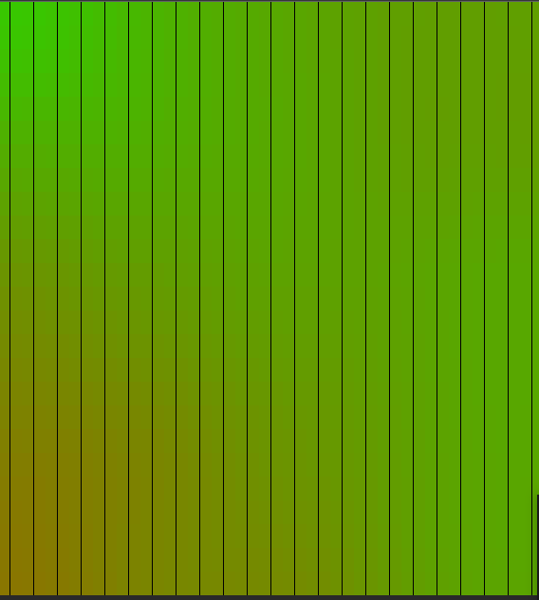

## Step 5

/*

Step 5: For each of the compasses generate a 3D noise value, using the

compass’ x and y coordinate as well as the frameCount so that the noise

values change over time. Make sure you scale the input parameters of the

noise function appropriately so that you get organic values out of it.

Use that noise value with map() to generate an angle between 0 and 720

degrees. Use that value to rotate the compass. If you’ve done things right

 your compasses should be rotating while the sketch is running.

If your lines are not rotating in the pattern seen above check how you are

 scaling the input parameters of noise(). Also study how each line rotates

 in the gif above.

*/

function compassGrid(){

  // your code here

  stroke(0);

  for (var i=0; i<25; i++) {

    for (var j=0; j<25; j++) {

      // translate to the center of each tile and draw compasses

      var tileCenter = createVector(width*i/25 + stepSize/2, height*j/25 + stepSize/2);

      // Create noise

      var n = noise(tileCenter.x/1000, tileCenter.y/1000, frameCount/50);

      // Create rotation

      var rot = map(n, 0, 1, 0, 720);

      push();

        translate(tileCenter.x, tileCenter.y);

        rotate(radians(rot));

        line(0, stepSize/2, 0, -stepSize/2);

      pop();

    }

  }

}

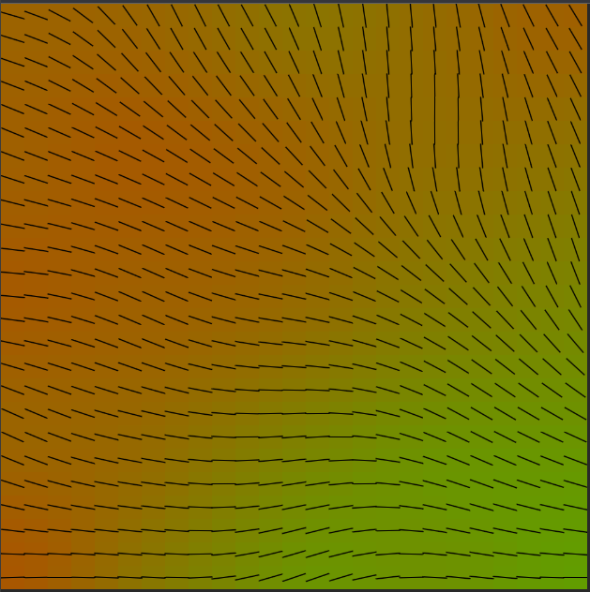

## Step 7

Code with the extension

var stepSize = 20;

var n;

var n1;

function setup() {

  createCanvas(500, 500);

}

///////////////////////////////////////////////////////////////////////

function draw() {

  rectMode(CENTER)

  background(125);

  colorGrid();

  compassGrid();

}

///////////////////////////////////////////////////////////////////////

function colorGrid(){

  // your code here

  for (var i=0; i<25; i++) {

    for (var j=0; j<25; j++) {

      // tile position

      var tileX = width*i/25 + stepSize/2;

      var tileY = height*j/25 + stepSize/2;

      //tile color

      var mouseMap = map(mouseX, 0,width, 20,40);

      var n = noise(tileX/1000, tileY/1000, frameCount/mouseMap);

      var from = color(255,0,0);

      var to = color(0,0,255);

      var inter = lerpColor(from, to, n);

      // draw tile

      fill(inter);

      noStroke();

      rect(tileX,tileY, stepSize, stepSize);

    }

  }

}

///////////////////////////////////////////////////////////////////////

/*

Ideas for further development

Make it your own by changing the colors and style.

Use the noise to change the color and length of the compass lines.

*/

function compassGrid(){

  // your code here

  stroke(0);

  for (var i=0; i<25; i++) {

    for (var j=0; j<25; j++) {

      // translate to the center of each tile and draw compasses

      var mouseMap2 = map(mouseX, 0,width, 20,40);

      var tileCenter = createVector(width*i/25 + stepSize/2, height*j/25 + stepSize/2);

      // Create noise

      n = noise(tileCenter.x/1000, tileCenter.y/1000, frameCount/mouseMap2);

      n1 = noise(tileCenter.x/1000, tileCenter.y/1000, frameCount/mouseMap2);

      // console.log(frameCount/mouseMap);

      // Create rotation

      var rot = map(n, 0, 1, 0, 720);

      var col = map(n1, 0, 1, 100, 255); // Extension: using noise to change the color of the line

      var len = map(n1, 0, 1, 10, 20); // Extension: Using noise to change the length of the line

      console.log(col);

      push();

        stroke(0,col,0);

        translate(tileCenter.x, tileCenter.y);

        rotate(radians(rot));

        line(0, len, 0, -len);

      pop();

    }

  }

}

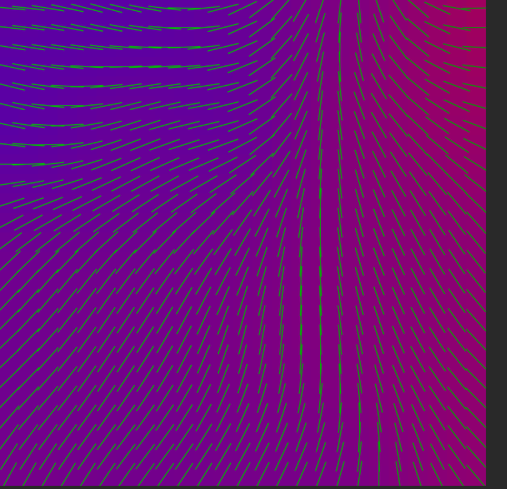

## Unforrtunaltely the template code is not complete foe the hack it

## 4_2DNoise

In 1D noise values are similar in time

In 2D times values are similar to the neighbors

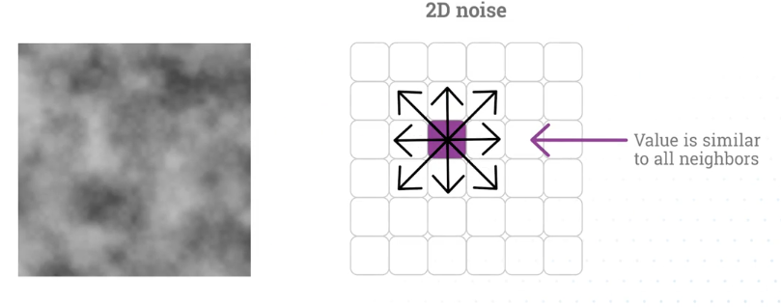

It is used to code clouds, smoke, fire …

I am at 5:34

Compare the 2D image obtained using random function and perlin noise generator

* Random function gives tchache like in TV
* Noise function (perlin) gives a very smooth figure



If we apply random noise we get tchahe like old TVs



If we apply perlin we get a nuch smoother image



The Perlin noise works by by adding multiple noises with different frequencies ti create a noise wave. In the noise waves there are multiple calls to the rando(0 function

These waves that are added together are called octaves. In p5 noise() comes with 4 octaves

We can seed the noise function using noiseSeed(10)

Noisedetail(4) the hgher the argument the more volatile the noise function



Lead to this



function setup() {

    createCanvas(100, 100);

    background(0);

}

function draw() {

    background(0);

    noiseDetail(7);

    noiseGrid();

}

function noiseGrid() {

    // Give each pixel a random color

    for (var x=0; x<width; x++) {

        for (var y=0; y<innerHeight; y++) {

            var n = noise(x/100,y/100); //A step of 1 is huge for the noise function so we divide by 100

            var c = map(n,0,1,0,255)

            stroke(c);

            point(x,y);

        }

    }

}





## 5_3D noise

We add one parameter to the noise function. It creates a mist that moves in time

function setup() {

    createCanvas(100, 100);

    background(0);

}

function draw() {

    background(0);

    noiseDetail(7);

    noiseGrid();

}

function noiseGrid() {

    // Give each pixel a random color

    for (var x=0; x<width; x++) {

        for (var y=0; y<innerHeight; y++) {

            var n = noise(x/100,y/100, frameCount/50); //A step of 1 is huge for the noise function so we divide by 100

            var c = map(n,0,1,0,255)

            stroke(c);

            point(x,y);

        }

    }

}



# Week 7

## Step 1

Step 1: Amend the colorGrid() function and create a

25x25 grid of rectangles. The rectangles should be of

width and height equal to stepSize, the global variable

 already provided. Set the fill to white and the stroke

 to black, to make sure the grid is correctly setup.

*/

function colorGrid(){

  // your code here

  fill(255);

  stroke(0);

  for (var i=0; i<25; i++) {

    for (var j=0; j<25; j++) {

      rect(width*i/25,height*j/25, stepSize, stepSize);

    }

  }

}



## Step 2

Lerpcolor()

<https://p5js.org/reference/#/p5/lerpColor>

Blends two colors to find a third color somewhere between them. The amt parameter is the amount to interpolate between the two values where 0.0 is equal to the first color, 0.1 is very near the first color, 0.5 is halfway in between, etc. An amount below 0 will be treated as 0. Likewise, amounts above 1 will be capped at 1. This is different from the behavior of [lerp()](https://p5js.org/reference/#/p5/lerp), but necessary because otherwise numbers outside the range will produce strange and unexpected colors.

/*

Step 2:

For each of the tiles generate a 3D noise value, using the tile’s x and y

coordinate as well as the frameCount so that the noise values change over

time. Make sure you scale the input parameters of the noise function

appropriately so that you get organic values out of it. Use that noise

value to lerp (aka interpolate) between red and green.Use the lerpColor()

function (see p5.js examples) to do so. Remove the rectangle’s stroke and

use color returned from the lerpColor() function to fill the rectangle. If

you’ve done things right you should see a grid of tiles with slowly

changing colors.

If the color of your rectangles are changing rapidly or are not smooth

like the gif above, double check how you have scaled the input parameters

for noise().

*/

function colorGrid(){

  // your code here

  for (var i=0; i<25; i++) {

    for (var j=0; j<25; j++) {

      // tile position

      var tileX = width*i/25;

      var tileY = height*j/25;

      //tile color

      var n = noise(tileX/1000, tileY/1000, frameCount/50);

      console.log(n);

      var from = color(255,0,0);

      var to = color(0,255,0);

      var inter = lerpColor(from, to, n);

      // draw tile

      fill(inter);

      noStroke();

      rect(tileX,tileY, stepSize, stepSize);

    }

  }

}

You get this and it is moving



## Step 3

/*

Step 3: Make the grid color change speed be dependent on the x coordinate

of the mouse (ie small mouseX, faster color changes).

*/

function colorGrid(){

  // your code here

  for (var i=0; i<25; i++) {

    for (var j=0; j<25; j++) {

      // tile position

      var tileX = width*i/25;

      var tileY = height*j/25;

      //tile color

      var n = noise(tileX/1000, tileY/1000, frameCount/mouseX);

      console.log(frameCount/mouseX)

      var from = color(255,0,0);

      var to = color(0,255,0);

      var inter = lerpColor(from, to, n);

      // draw tile

      fill(inter);

      noStroke();

      rect(tileX,tileY, stepSize, stepSize);

    }

  }

}

## Step 4

/*

Step 4: Amend the compassGrid() function to create a grid of 25x25 lines

of length stepSize. Make sure each compass is at the center of each tile.

By default they should all be pointing up. You should use translate()

to move to the center of each grid.

*/

function compassGrid(){

  // your code here

  stroke(0);

  for (var i=0; i<25; i++) {

    for (var j=0; j<25; j++) {

      // translate to the center of each tile

      var tileCenter = createVector(width*i/25 + stepSize/2, height*j/25 + stepSize/2);

      push();

        translate(tileCenter.x, tileCenter.y);

        // rotate(radians(68));

        line(0, stepSize/2, 0, -stepSize/2);

      pop();

    }

  }

}



## Step 5

/*

Step 5: For each of the compasses generate a 3D noise value, using the

compass’ x and y coordinate as well as the frameCount so that the noise

values change over time. Make sure you scale the input parameters of the

noise function appropriately so that you get organic values out of it.

Use that noise value with map() to generate an angle between 0 and 720

degrees. Use that value to rotate the compass. If you’ve done things right

 your compasses should be rotating while the sketch is running.

If your lines are not rotating in the pattern seen above check how you are

 scaling the input parameters of noise(). Also study how each line rotates

 in the gif above.

*/

function compassGrid(){

  // your code here

  stroke(0);

  for (var i=0; i<25; i++) {

    for (var j=0; j<25; j++) {

      // translate to the center of each tile and draw compasses

      var tileCenter = createVector(width*i/25 + stepSize/2, height*j/25 + stepSize/2);

      // Create noise

      var n = noise(tileCenter.x/1000, tileCenter.y/1000, frameCount/50);

      // Create rotation

      var rot = map(n, 0, 1, 0, 720);

      push();

        translate(tileCenter.x, tileCenter.y);

        rotate(radians(rot));

        line(0, stepSize/2, 0, -stepSize/2);

      pop();

    }

  }

}



## Step 7

Code with the extension

var stepSize = 20;

var n;

var n1;

function setup() {

  createCanvas(500, 500);

}

///////////////////////////////////////////////////////////////////////

function draw() {

  rectMode(CENTER)

  background(125);

  colorGrid();

  compassGrid();

}

///////////////////////////////////////////////////////////////////////

function colorGrid(){

  // your code here

  for (var i=0; i<25; i++) {

    for (var j=0; j<25; j++) {

      // tile position

      var tileX = width*i/25 + stepSize/2;

      var tileY = height*j/25 + stepSize/2;

      //tile color

      var mouseMap = map(mouseX, 0,width, 20,40);

      var n = noise(tileX/1000, tileY/1000, frameCount/mouseMap);

      var from = color(255,0,0);

      var to = color(0,0,255);

      var inter = lerpColor(from, to, n);

      // draw tile

      fill(inter);

      noStroke();

      rect(tileX,tileY, stepSize, stepSize);

    }

  }

}

///////////////////////////////////////////////////////////////////////

/*

Ideas for further development

Make it your own by changing the colors and style.

Use the noise to change the color and length of the compass lines.

*/

function compassGrid(){

  // your code here

  stroke(0);

  for (var i=0; i<25; i++) {

    for (var j=0; j<25; j++) {

      // translate to the center of each tile and draw compasses

      var mouseMap2 = map(mouseX, 0,width, 20,40);

      var tileCenter = createVector(width*i/25 + stepSize/2, height*j/25 + stepSize/2);

      // Create noise

      n = noise(tileCenter.x/1000, tileCenter.y/1000, frameCount/mouseMap2);

      n1 = noise(tileCenter.x/1000, tileCenter.y/1000, frameCount/mouseMap2);

      // console.log(frameCount/mouseMap);

      // Create rotation

      var rot = map(n, 0, 1, 0, 720);

      var col = map(n1, 0, 1, 100, 255); // Extension: using noise to change the color of the line

      var len = map(n1, 0, 1, 10, 20); // Extension: Using noise to change the length of the line

      console.log(col);

      push();

        stroke(0,col,0);

        translate(tileCenter.x, tileCenter.y);

        rotate(radians(rot));

        line(0, len, 0, -len);

      pop();

    }

  }

}



# Week 8

## Video Intro to trigonometry

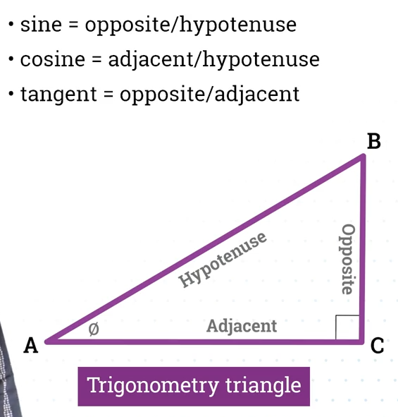

## Video polar coordinates

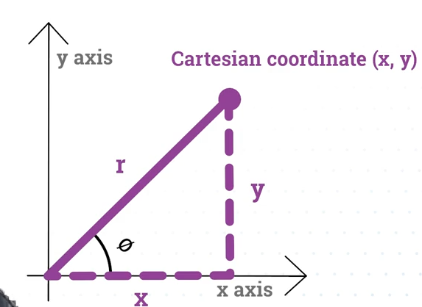

(r, theta) are the polar coordinates

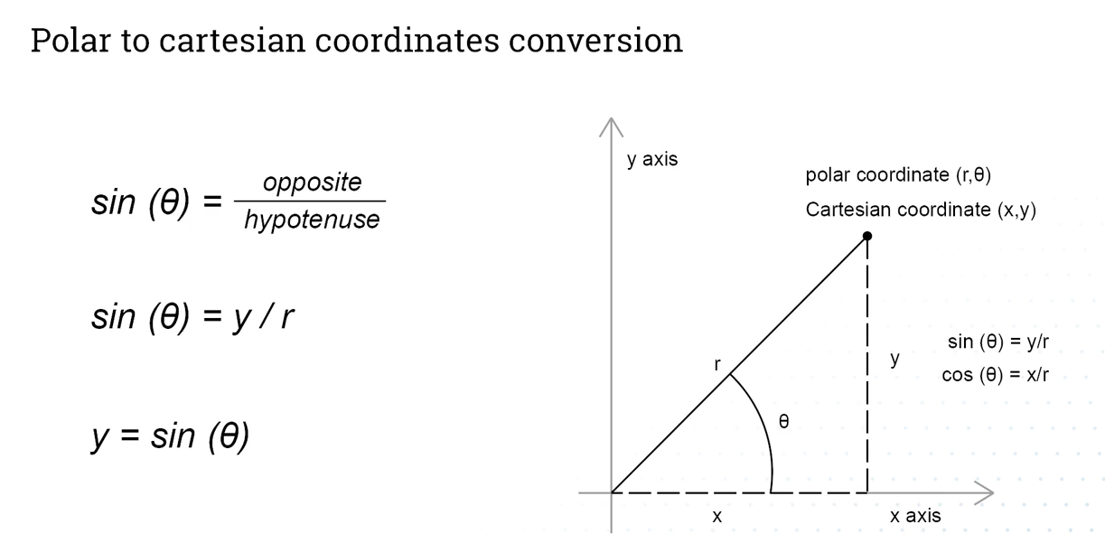

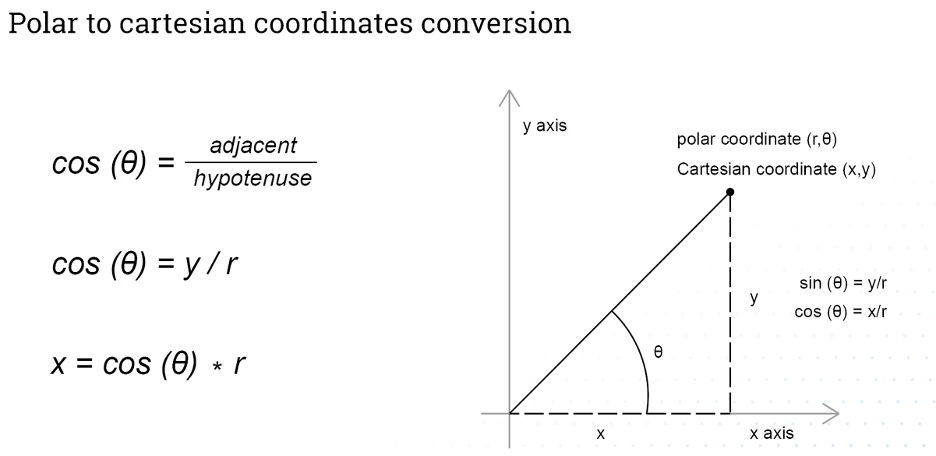

## Video coding a circle

Q. Step 1 Draw circles evert 20 degrees like this

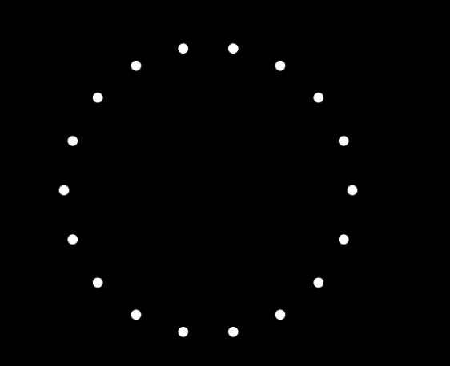

function setup() {

    createCanvas(900, 600);

    background(0);

    //  By default p5 reads angles in radians. We change that to degrees

    // otherwise we would write radians(theta)

    angleMode(DEGREES);

}

function draw() {

    background(0);

    translate(width/2, height/2);

    fill(255);

    var radius = 200;

    for (var theta=0; theta<360; theta=theta+20) {

        var x = cos(theta) * radius;

        var y = sin(theta) * radius;

        ellipse(x, y, 15, 15);

    }

}

Q. Draw one circle that rotates around the center of the frame

function setup() {

    createCanvas(900, 600);

    background(0);

    //  By default p5 reads angles in radians. We change that to degrees

    // otherwise we would write radians(theta)

    angleMode(DEGREES);

}

function draw() {

    background(0);

    translate(width/2, height/2);

    fill(255);

    var radius = 200;

    // Framecount changes from 0 to 60 in one second. So theta will increase by 60 degrees every second

    var theta = frameCount;

    var x = cos(theta) * radius;

    var y = sin(theta) * radius;

    ellipse(x, y, 15, 15);

}

Q. Now create an Archimedean spiral that keeps increasing

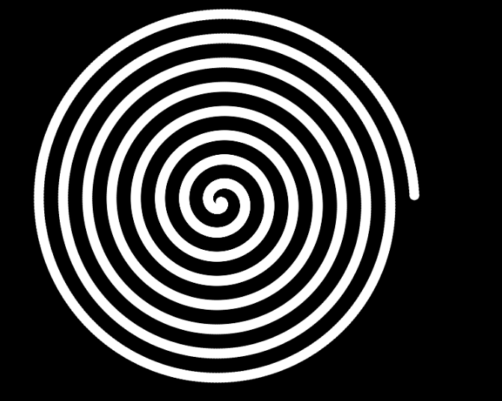

function setup() {

    createCanvas(900, 600);

    background(0);

    //  By default p5 reads angles in radians. We change that to degrees

    // otherwise we would write radians(theta)

    angleMode(DEGREES);

}

function draw() {

    // background(0);

    // We remove background(0) to keep all the drawn circles

    noStroke()

    translate(width/2, height/2);

    fill(255);

    // We incrememnt the radius to get the archimedian spiral

    var radius = frameCount/10;

    // Framecount changes from 0 to 60 in one second. So theta will increase by 60 degrees every second

    var theta = frameCount;

    var x = cos(theta) * radius;

    var y = sin(theta) * radius;

    ellipse(x, y, 15, 15);

}

## Oscillation for movement

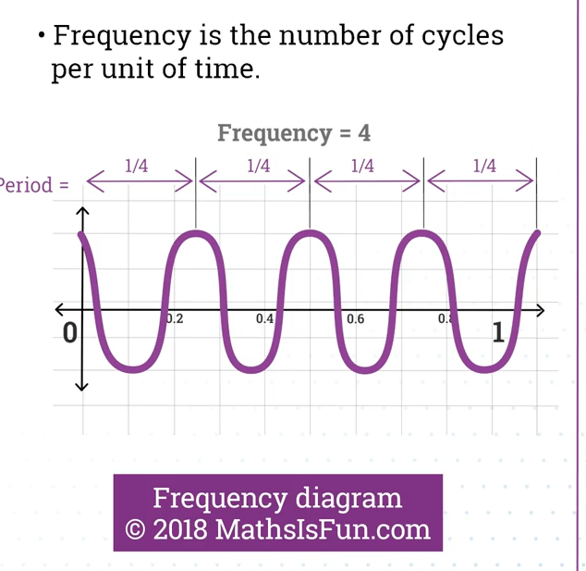

Frequency = 4 hertz

## Coding Oscillation

Q. First create a circle that oscillates only on the x axis around the center of the screen.

function setup() {

    createCanvas(900, 600);

    background(0);

    angleMode(DEGREES);

}

function draw() {

    background(0);

    fill(255);

    translate(width/2, height/2)

    var amp = width/2;

    var locX = sin(frameCount) * amp;

    ellipse(locX, 0, 30, 30);

}

Q. add a phase and a frequency to the code

function setup() {

    createCanvas(900, 600);

    background(0);

    angleMode(DEGREES);

}

function draw() {

    background(0);

    fill(255);

    translate(width/2, height/2)

    var amp = width/2;

    var period = 360; // It takes period/60 seconds for the ball to get back to place

    var phase = 0; // starting angle

    var freq = 1;

    var locX = sin(frameCount*6*freq+phase) * amp;

    ellipse(locX, 0, 30, 30);

}

## Video: Using additive synthesis

Additive synthesis Is creating forms using combinations of waves

Q. First create a sin wave

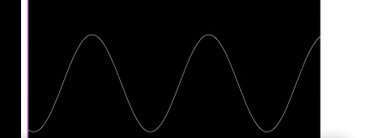

function setup() {

    createCanvas(900, 600);

    background(0);

    angleMode(DEGREES);

}

function draw() {

    background(0);

    stroke(255);

    translate(0, height/2);

    beginShape();

    for (var x=0; x<width; x++) {

        var wave1 = sin(x) * height/4;

        vertex(x, wave1);

    }

    endShape();

}

Q. Then make it move

function setup() {

    createCanvas(900, 600);

    background(0);

    angleMode(DEGREES);

}

function draw() {

    background(0);

    stroke(255);

    translate(0, height/2);

    beginShape();

    for (var x=0; x<width; x++) {

        var wave1 = sin(x+frameCount) * height/4;

noFill();

        vertex(x, wave1);

    }

    endShape();

}

Q. Now buid this wave

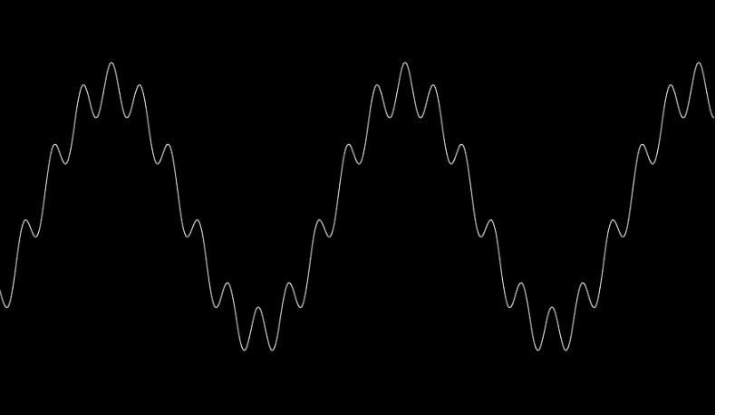

We add another wave with different frequency and amplitude

function setup() {

    createCanvas(900, 600);

    background(0);

    angleMode(DEGREES);

}

function draw() {

    background(0);

    stroke(255);

    translate(0, height/2);

    beginShape();

    for (var x=0; x<width; x++) {

        var wave1 = sin(x+frameCount) * height/4;

        var wave2 = sin(x*10+frameCount) * height/20;

        noFill();

        vertex(x, wave1 + wave2);

    }

    endShape();

}

Q. Now add an organic noise

function setup() {

    createCanvas(900, 600);

    background(0);

    angleMode(DEGREES);

}

function draw() {

    background(0);

    stroke(255);

    translate(0, height/2);

    beginShape();

    for (var x=0; x<width; x++) {

        var wave1 = sin(x+frameCount) * height/4;

        var wave2 = sin(x*10+frameCount) * height/20;

        var wave3 = noise(x/10+frameCount/100)*100;

        noFill();

        vertex(x, wave1 + wave2 + wave3);

    }

    endShape();

}

## Hack it: circle additive

Starting code and shape:

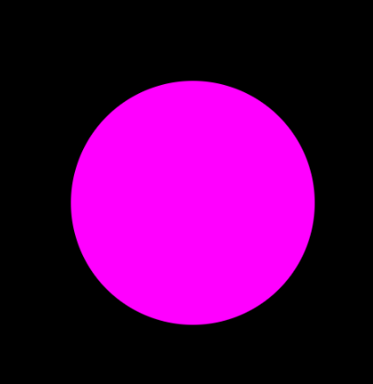

function setup() {

    createCanvas(550,550);

    background(0);

    angleMode(DEGREES);

}

/*

1. Add one line of code to set the value of wave1 which

will use a sine wave. If you’ve done things right you

should see something like the image below. If you don't,

check the parameter passed to sin() and how you scale

the returned value.

*/

/////////////////////////////////////////////////

function draw() {

    background(0);

    noStroke();

    fill(255,0,255);

    translate(width/2,height/2);

    //ADDITIVE SYNTHESIS IN A CIRCLE

    var radius = 150;

    beginShape();

    for (var theta=0; theta<360; theta+=1){

      var wave1 = 0;// your sine code here

      var wave2 = 0;// your noise code here

      var r = radius + wave1 + wave2;

      var x = cos(theta) * r;

      var y = sin(theta) * r;

      vertex(x,y);

    }

    endShape(CLOSE);

}

Q. Change the shape into this by changing wave1

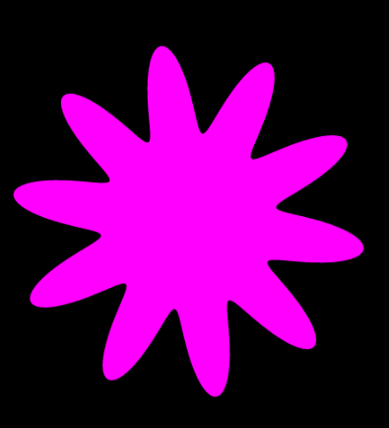

We change wave1 to

var wave1 = sin(theta*10)*50;

so

function setup() {

    createCanvas(550,550);

    background(0);

    angleMode(DEGREES);

}

/////////////////////////////////////////////////

function draw() {

    background(0);

    noStroke();

    fill(255,0,255);

    translate(width/2,height/2);

    //ADDITIVE SYNTHESIS IN A CIRCLE

    var radius = 150;

    beginShape();

    for (var theta=0; theta<360; theta+=1){

      var wave1 = sin(theta*10)*50;// your sine code here

      var wave2 = 0;// your noise code here

      var r = radius + wave1 + wave2;

      var x = cos(theta) * r;

      var y = sin(theta) * r;

      vertex(x,y);

    }

    endShape(CLOSE);

}

Q. Now add noise to wave 2 to get

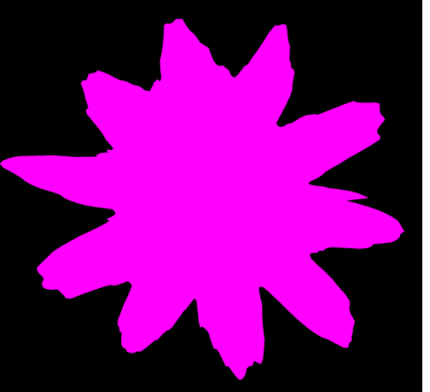

var wave2 = noise(theta/10)*100;

Q. Now add animation using frameCount on noise,

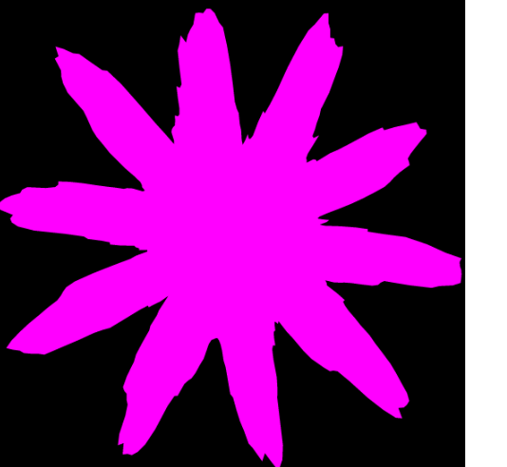

      var wave2 = noise(theta/5+frameCount/100)*100;// your noise code here

Here is the whole code

function setup() {

    createCanvas(550,550);

    background(0);

    angleMode(DEGREES);

}

/////////////////////////////////////////////////

function draw() {

    background(0);

    noStroke();

    fill(255,0,255);

    translate(width/2,height/2);

    //ADDITIVE SYNTHESIS IN A CIRCLE

    var radius = 150;

    beginShape();

    for (var theta=0; theta<360; theta+=1){

      var wave1 = sin(theta*10)*75;// your sine code here

      var wave2 = noise(theta/5+frameCount/100)*100;// your noise code here

      var r = radius + wave1 + wave2;

      var x = cos(theta) * r;

      var y = sin(theta) * r;

      vertex(x,y);

    }

    endShape(CLOSE);

}

# Week 9

## History of fractals

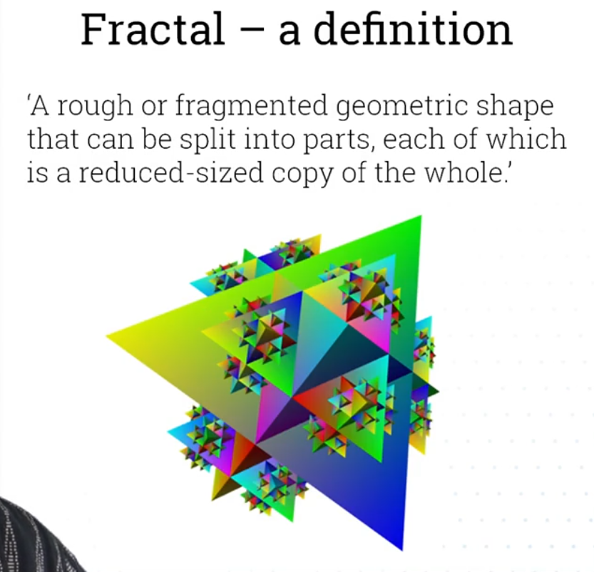

History of fractals

Fractals are a mathematical concept that we owe to Mandelebrot. Before them, our classic geometric shapes were unable to replicate the forms observed in nature. Fractals are a new gepmetric model that can replicate things we see in nature

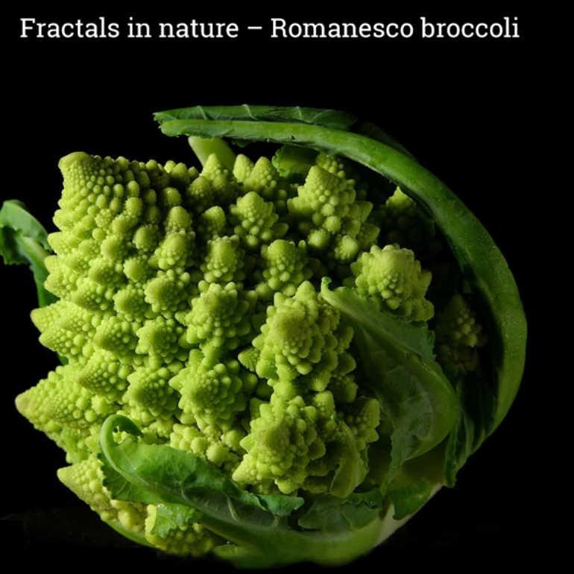

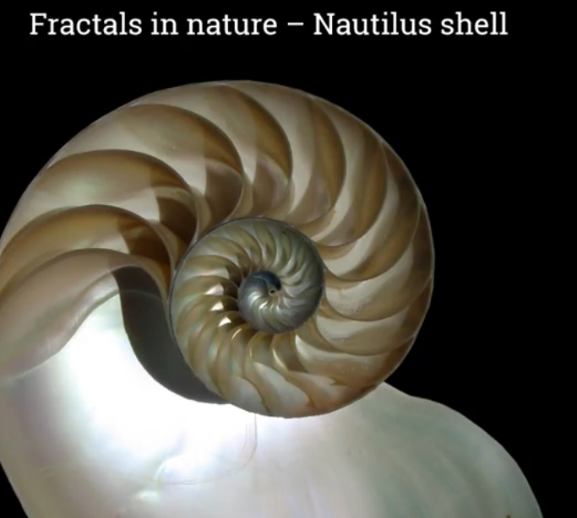

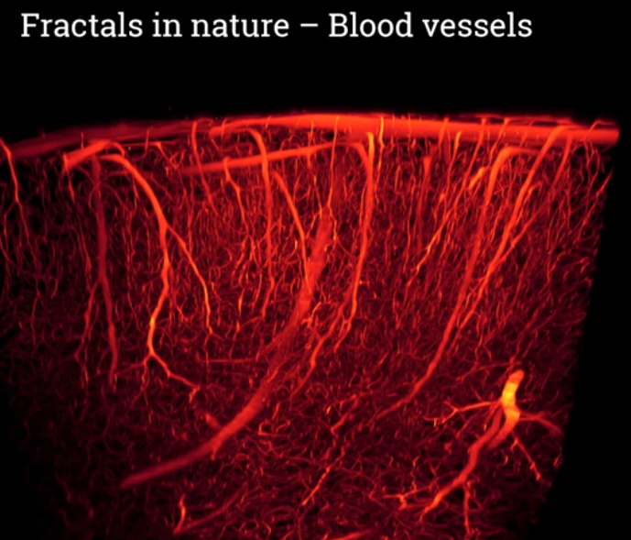

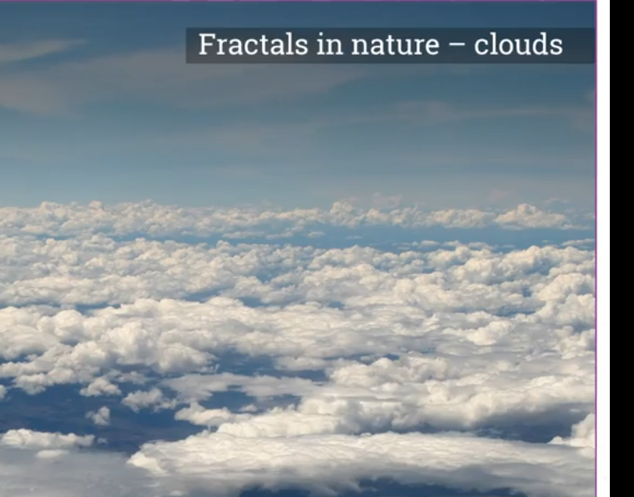

## Serpinski carpet

### The Serpinki forms

All these forms are obtained using the same technique: we subdivide a shape into smaller copies of itself, we remove one or more copies, and continue recursively

#### Serpinski triangle:

* Divide an equilateral triangle into 4 equilateral triangles
* Remove the middle triangle
* Recurse the steps above on the remaining triangles

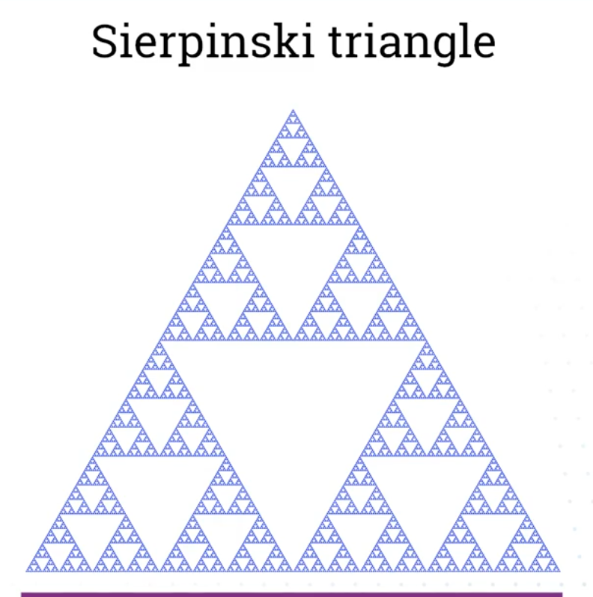

#### Serpinski carpet

This is Serpinki with a square. We follow the same procedure as above. That is:

We start with a square.

* Divide the square into 9 congruent subsquares
* Remove the square in the middle
* Then repeat the procedure with the 8 remaining subsquares

This is step 1. We remove the middle square which is square 9 here

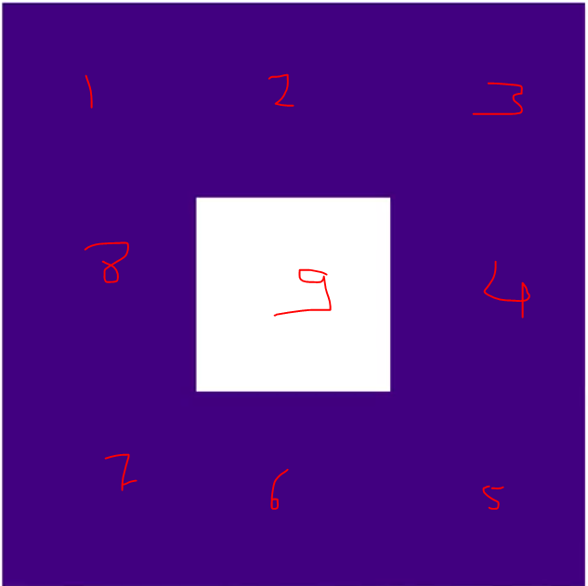

Step 2: We repeat the procedure above with ach of the squares 1 to 8

#### The Menger sponge

This is obtained by applying that procedure on a cube

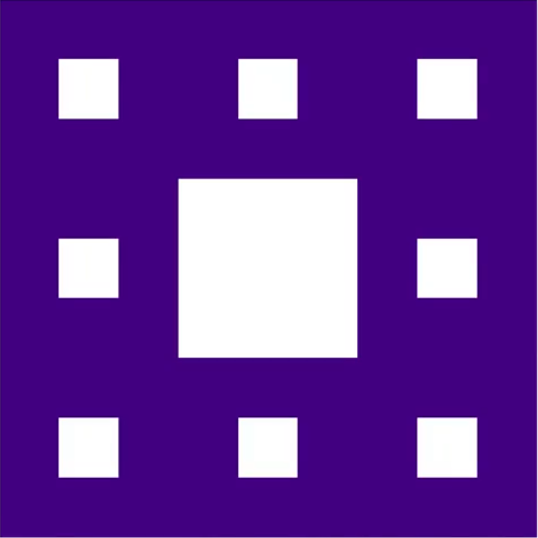

Step 3:

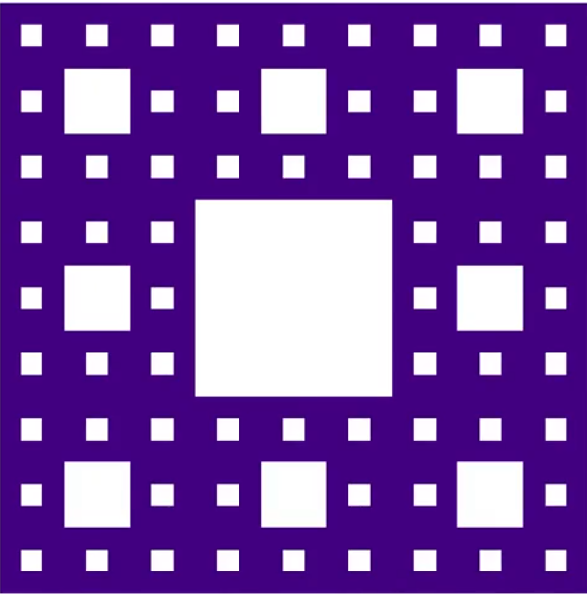

Step 4:

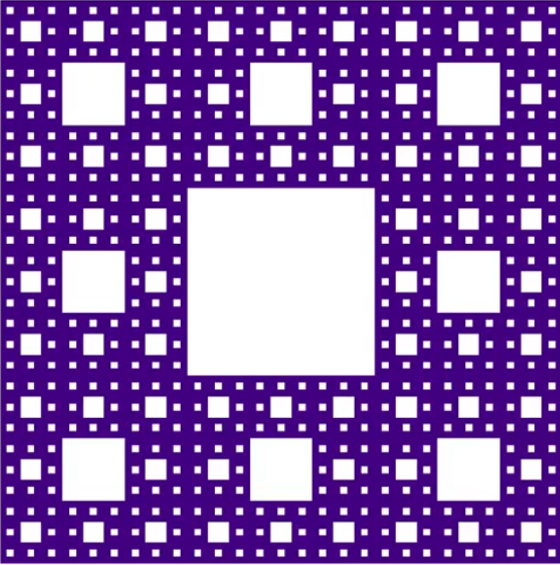

We ply the same procedure forever

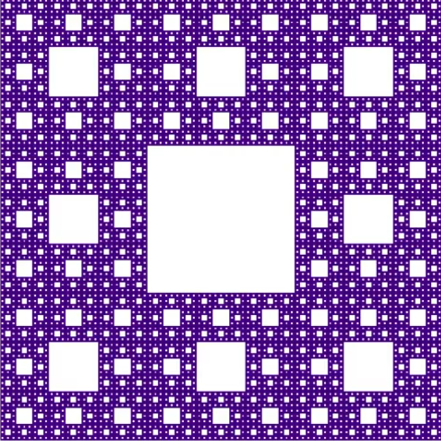

NJow with live server I must open localhost manually after I right click on index.html and gto to lkkive preview

<http://localhost:61274/>

var startSize;

var calls;

function setup() {

  createCanvas(900,900);

  background(200);

  fill(0);

  noStroke();

  noSmooth();

  rectMode(CENTER);

  startSize = pow(3, 6); // 3^6

  calls = 0;

}

function draw() {

  translate(width/2, height/2);

  rect(0,0,startSize/3,startSize/3);

  yow(startSize);

  noLoop(); // no dynamic, we do not update

}

function yow(side) {

  calls++; //

  side = side/3;

  //if size greater than 1 pixel keep dividing

  if (side >= 1) {

    fill(0);

    rect(0,0,side,side);

    push();

    translate(-side,0);

    yow(side);

    pop();

    push();

    translate(-side,-side);

    yow(side);

    pop();

    push();

    translate(0,-side);

    yow(side);

    pop();

    push();

    translate(side,-side);

    yow(side);

    pop();

    push();

    translate(side,0);

    yow(side);

    pop();

    push();

    translate(side,side);

    yow(side);

    pop();

    push();

    translate(0,side);

    yow(side);

    pop();

    push();

    translate(-side,side);

    yow(side);

    pop();

  }

}

